Title: Bold, Times 14, Centred

Authors, the name of the presenting author underlined, in Times 12, centred, as in the following:

R.A. Alpher, H. Bethe¹, G. Gamow²

Affiliation: Times 10, centred: xxx, ¹yyy, ²zzz, with author’s email in bold

There must be one blank line between the title, the authors’ names and their affiliation and two blank lines between the affiliation and the beginning of the body text without any punctuation marks at the end of these lines.

All abstracts must be written in English and occupy a maximum of 1 page A4 written in times 12, alignment in mode “justify”. Please make sure to respect the following margins: top, bottom, right: 2.5 cm; left: 3.0 cm.

Reference citations [1] are shown in the text by a number in brackets and follow one double space below the body text under the heading “References” in Times 10.

If figures or images are included in the abstract, please insert them as .jpg files.

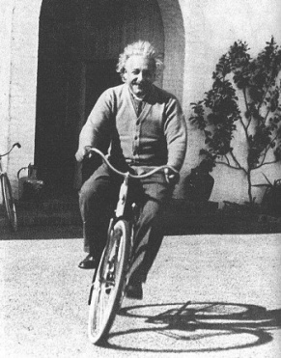

Figure 1: The figure caption is written in Times 10 and aligned with the picture.

In order to ensure a smooth abstract booklet preparation, please do not insert text or references in “footnote” mode or other encoding.

References
[1] - The heading “References” follows one double space below the body text in times 10 bold. Reference citations are shown in the text by a numeral in brackets and cited under the heading “References” in times 10.
[2] - J.D. Watson and F.H.C. Crick, Nature 171, 737 (1953).

Please submit your abstract in Word format (.doc) ONLY! You can use this file.

Save your abstract under your family name typed in small letter, for example “bond.doc” submitted by James Bond.

