2022
andy_connection_help

CONNECT TO DIFFRACT22BLISS CONSOLE TO LOOK/CONTROL THE EXPERIMENT

- Type on internet browser search bar: remote.esrf.fr
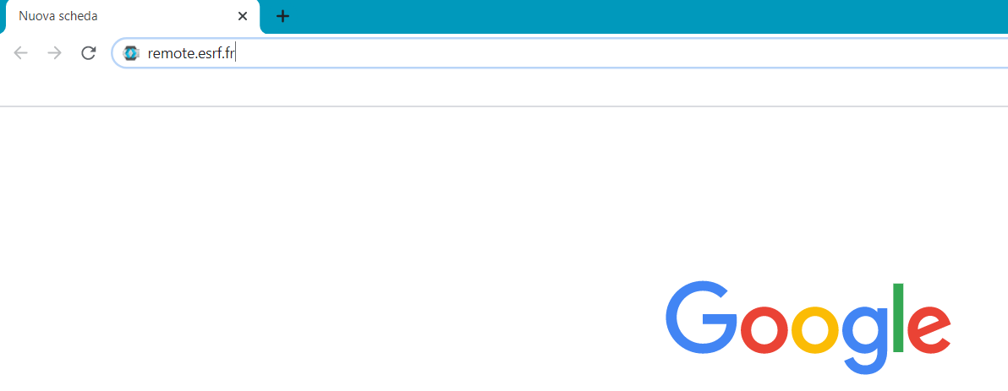
- Log-in with your ESRF site credentials, you are connecting via APACHE GUACAMOLE

- Choose Beamlines (click on the “+”) id22 diffract22bliss (Console)

- Now you are connected to the main beamline computer, and you can manage your experiment:
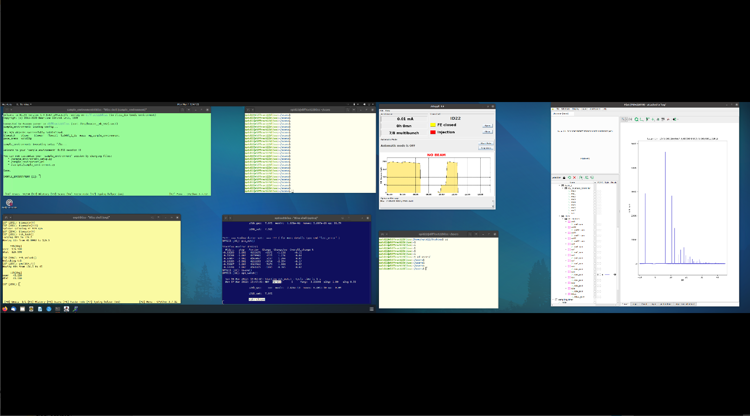
To zoom in: push at the same time “alt ctrl shift” and choose the zoom (zoom option is at the bottom), then push again “alt ctrl shift” to close the zoom window
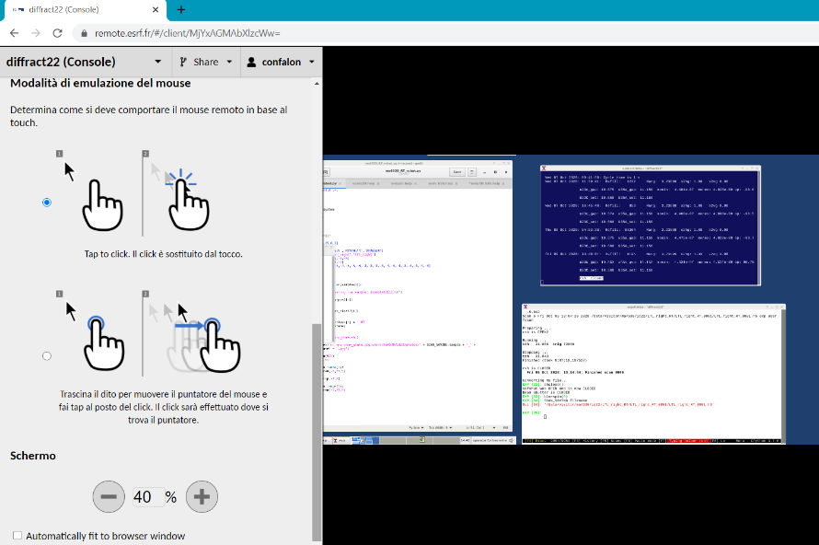

Through the Console mode on diffract22bliss, you usually see:
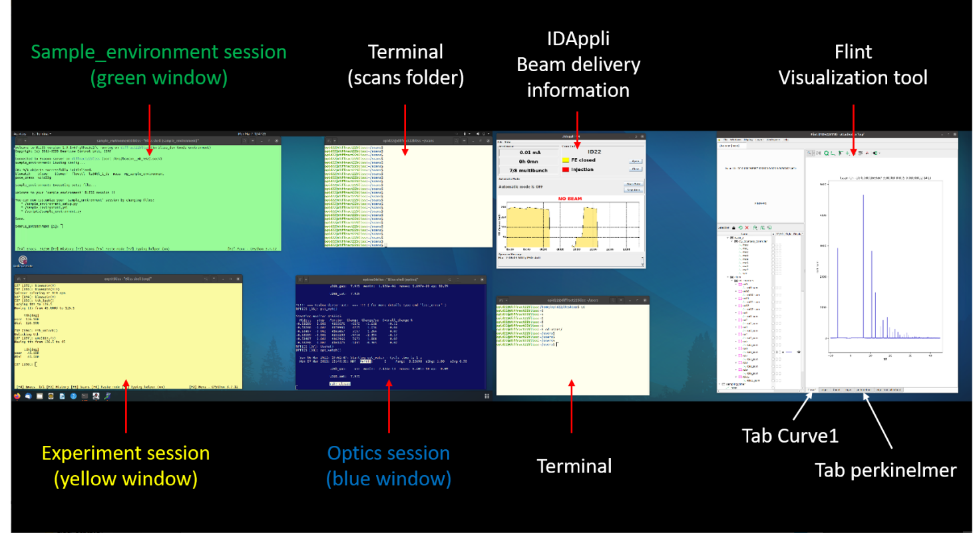
- Experiment session (yellow window), from which to control the experiment

- Optics session (blue window), where some information about beamline optics is displayed

- Sample_Environment session (green window), not always open, mainly for cryostat experiments

- Flint window: Flint is a visualization tool to follow data collection in live. The Flint window appears automatically when data collection starts. For high-resolution data, it shows data collection of one of the thirteen detectors in real time (tab Curve1). Choose the channel roi6_sum. For data collection using the Perkin detector, 2D images can be seen on the tab perkinelmer. You can follow a profile over the 2D patterns using “Define a directed line profile” option (toolbar at the top).

- IDAppli: gives information about the beam/machine status.

Tips:

- To open a terminal window: right click on the Desktop, choose “Open terminal here” or “Open in terminal”. Type “cd” and press Enter in the terminal. Then, you are ready to navigate to any relevant folder.

- Macros: all user macros are in the “scans” folder (after opening a terminal, type: cd scans). To edit a macro, type: gedit macro_name.py &. To copy a macro under a new name, type: cp macro_old_name.py macro_new_name.py

- To close a Bliss session (e.g. after a crash), type: “ctrl d” in the Bliss session. To re-open the Bliss session (usually Exp), double click on the corresponding icon on the desktop:
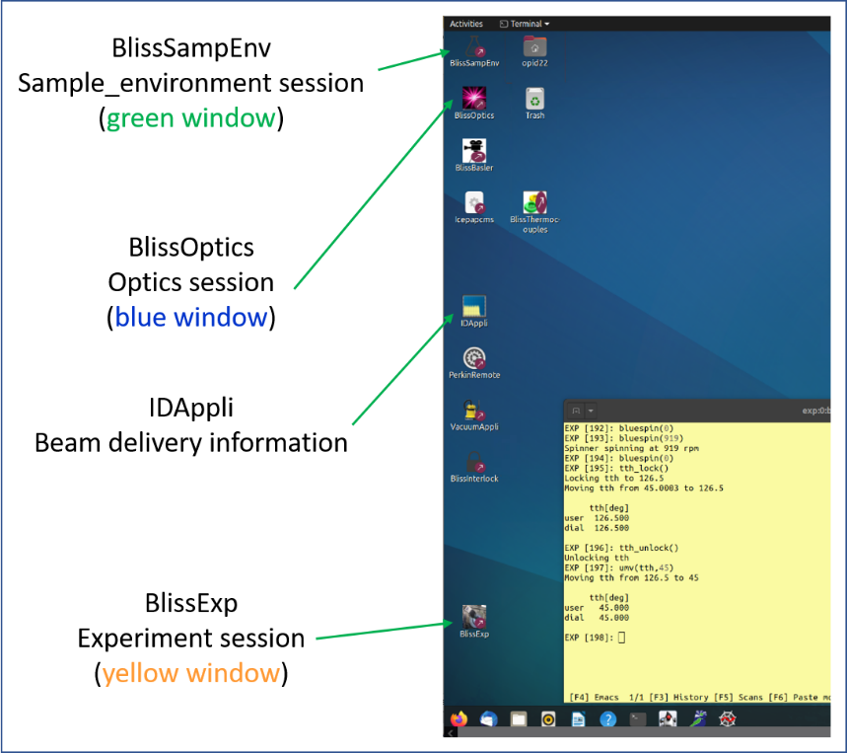

For the commands to collect data, refer to the file andy_EBS.help or andy2d_EBS.help

TREAT YOUR DATA

Option 1 (valid for the time of your experiment)
- Connect to Guacamole, as previously explained (remote.esrf.fr), using your ESRF site credentials, and choose diffract22new
- Login as opid22 (password tonic22)

- Move to users/name_of_the_experiment folder (cd, cd users/name_experiment)
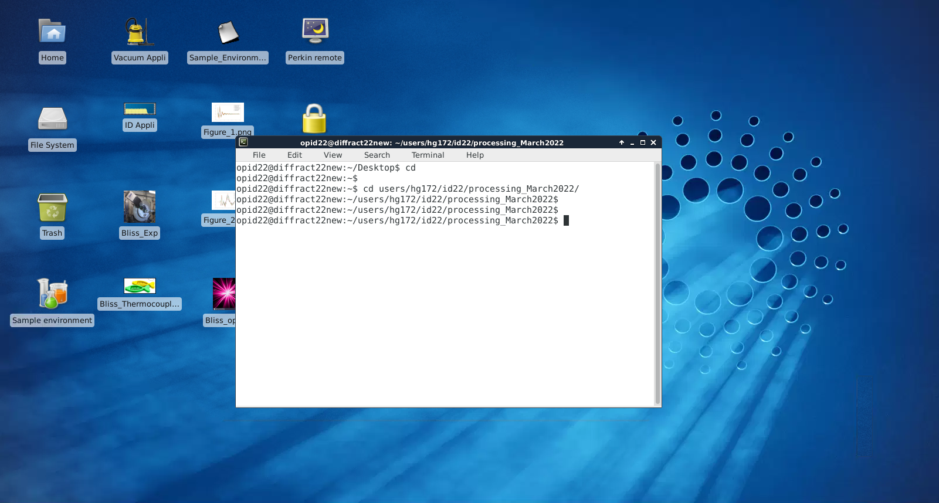
- To treat your data, refer to andy2d_EBS.help (2D data collection) or andy_EBS.help (high-resolution data)

Option 2 (valid after the end of the experiment)
- Use a NOmachine software, download it here http://www.nomachine.com
- Create a new connection:
Host: firewall.esrf.fr
Protocol: SSH
Port: 5622

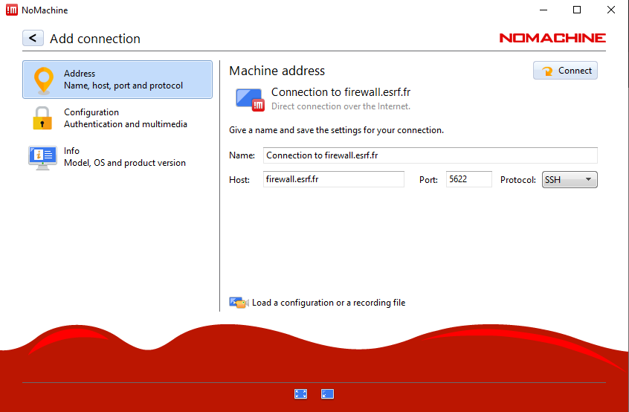

- Connect using your experiment name (e.g. hg172) and corresponding password (written in the A form, ask your main proposer).

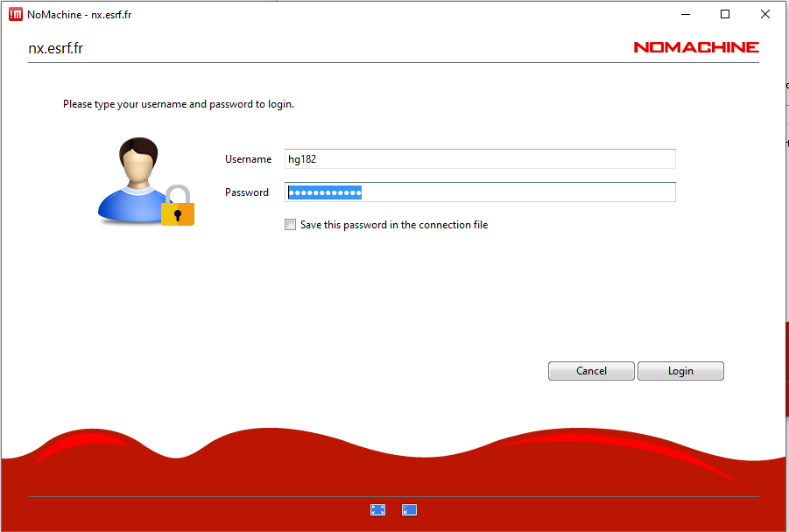

- First time: create a new virtual desktop, choose the default settings in the next step. You can also resize the window to the client monitor as an option. Once this is done, you should see the desktop of a Linux computer.

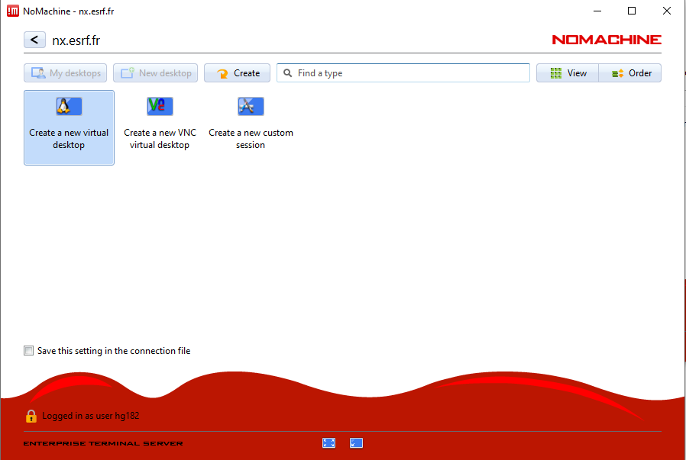

- To see your data, open a terminal (right click on the desktop, Open Terminal here), type: cd, then navigate to your user folder: id22/

- In order to use ID22 specific softwares such as id22sum.py, you need to connect first on the diffract22new computer. To do so, open a terminal, connect to diffract22new by typing: “ssh -X opid22@diffract22new” (password: tonic22). Go to your user folder: cd users/experiment_name/id22/

- Treat your data following instructions reported in andy2d_EBS.help (2D data collection) or andy_EBS.help (high-resolution data)

DOWNLOAD YOUR DATA
Follow instruction reported here: http://www.esrf.eu/UsersAndScience/Experiments/MX/How_to_use_our_beamlines/Prepare_Your_Experiment/Backup/SFTP
Briefly: download Filezilla software, click on File Manage site new site
Protocol: SFTP – SSH File Transfer Protocol
Hostname: firewall.esrf.fr
Username: name of the experiment
Port Number: 5022
Password: password of the experiment (reported in the Aform, User Portal)
and then connect, navigate to your experiment folder and then transfer your data in your computer.

