Some more help for XRD analysis with PyMca, HG159

To use PyMca for XRD background correction:
click on stack filtering option:
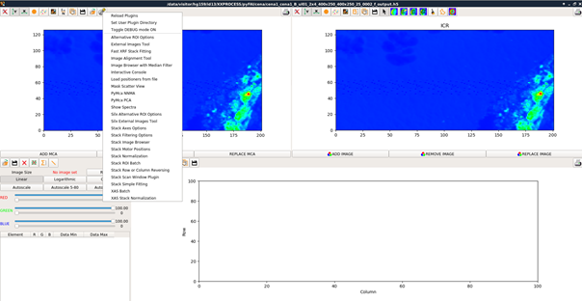
then select subtract SNIP 1D background

here conditions I tested on a sample analyzed during HG159 which worked well:
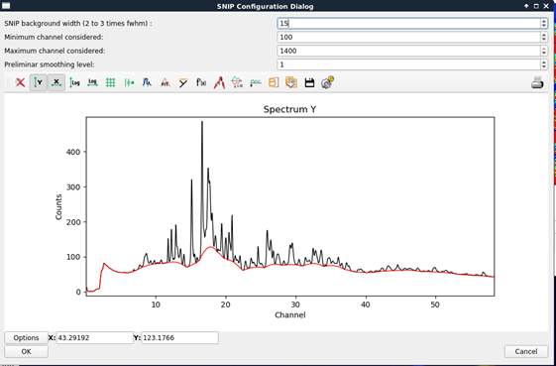

After background correction, you can calculate ROIs but also, PCA and NNMA. Here an example of NNMA I used:
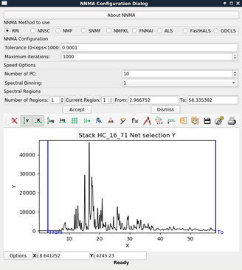
It gave very good results in identifying regions of different compositions.

