**Use of PyMCA to analyse-ray fluorescence and diffraction imaging data**

**Marine Cotte**

Application to paint cross-section, HG159, October 2020

# X-ray Fluorescence data (very few cases, Cena, Christelle; fit already made)

# Open the raw data with PyMca

* Open the main hdf5 file
* Find the scan you want to analyse and note the number of pixels in horizontal and vertical (*below 301 and 301*):

*akmap_lut ustry (horizontal motor in mm) 3.09 (starting position) 3.49 (ending position) 301 pixels ustrz (vertical motor in mm) -7.91 (starting position) -7.51 (ending position) 301 pixels*

* Unroll the relevant scan until you see measurement<xmap2_det0 and right click on it

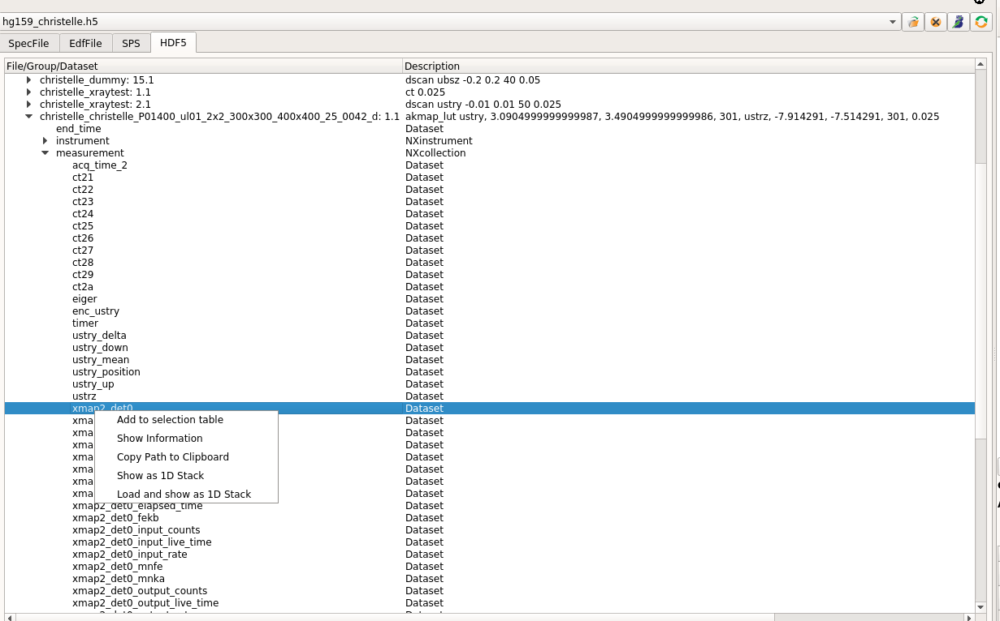

Select “load and show as 1D stack”

Enter in the number of columns with number of pixels given in the scan name. By clicking on number of rows, the value should correspond to the one given for the vertical axis.

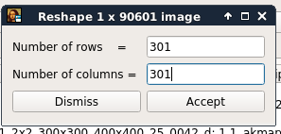

ROI imaging displays something like that

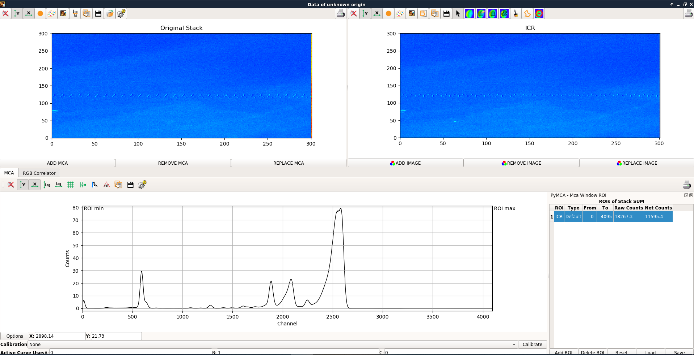

calculated intensity on a Region Of Interest (ROI)

Integrated intensity

Fluorescence spectra

Definition of ROI

* 1. Normalization by the incident beam

Select Plugins button< **Stack normalization**

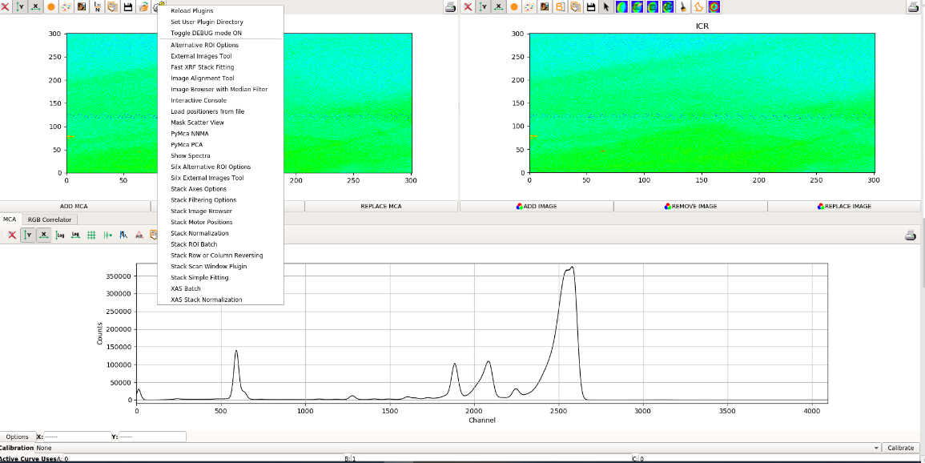

Then **Image I/Io normalization**

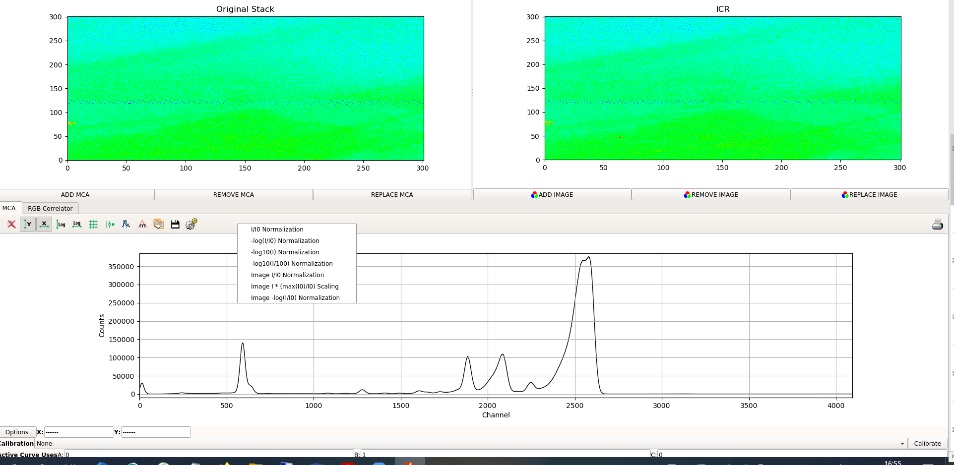

select .h5 extension, find the relevant .h5 file

then find back the same akmap

unroll the scan up to see "measurement" and go down to "ct24" that you should select, OK

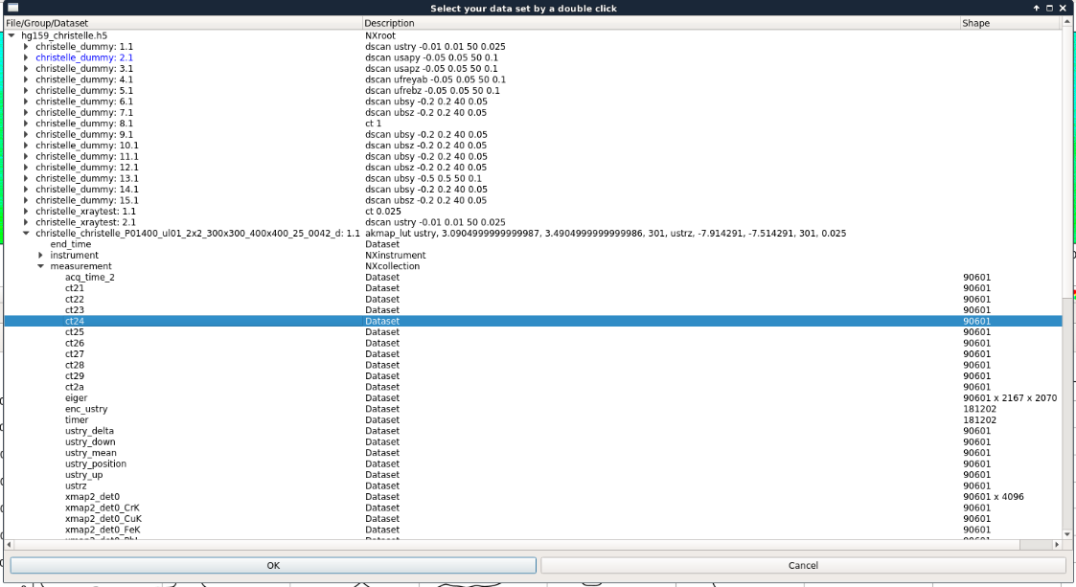

from then the map is normalized by the intensity of the incoming beam.

* 1. Procedure to fit the map

- First you can check the fit quality:

In the bottom panel where you have the sum spectrum, click on "**fit<Advanced**"

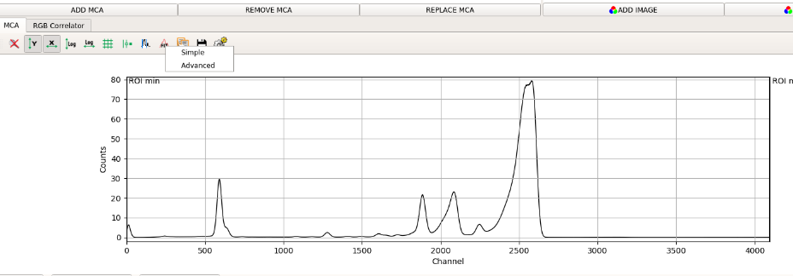

Click on OK to close the pop-up window

The fit window is open:

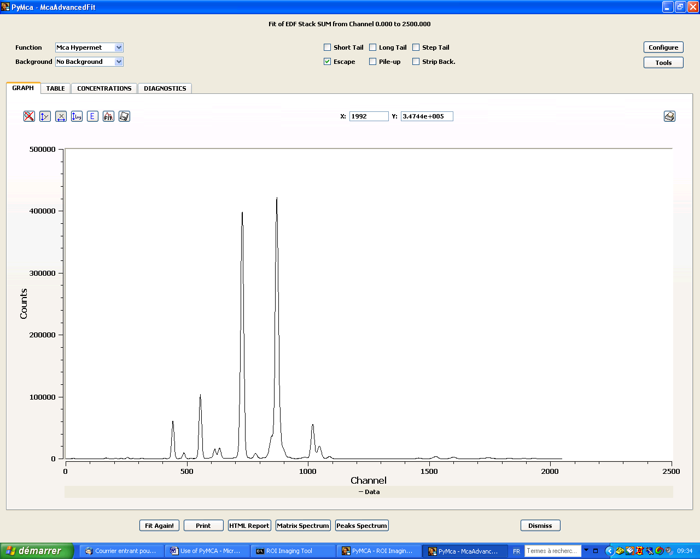

Then click on **Configure**

Then, either you define totally a new configuration or you can just adapt a previous known configuration.

**Load**= … open a configuration

Then **Fit again**

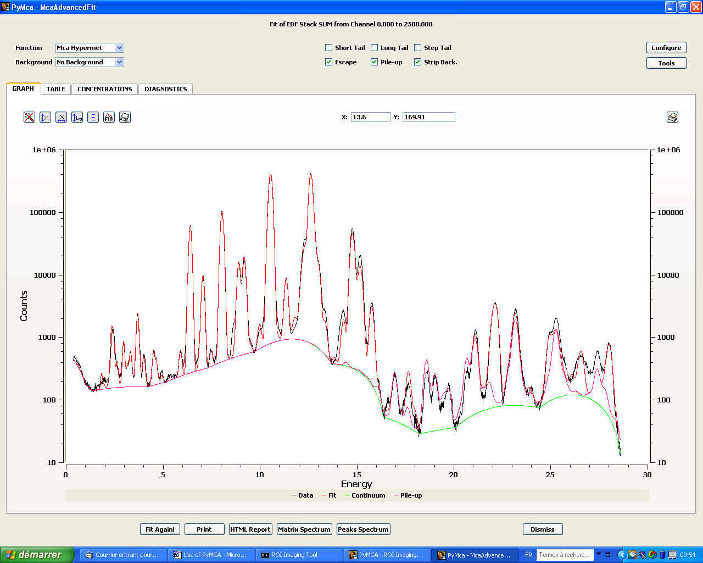

Then, adjust the configuration file (in particular the choice of elements).

When the fit is good, **Configure**<**save** the configuration file.

Then, you should save a similar configuration file but containing less degrees of freedom (a configuration file that will be used routinely in the batch process). In particular, it is important to change some options:

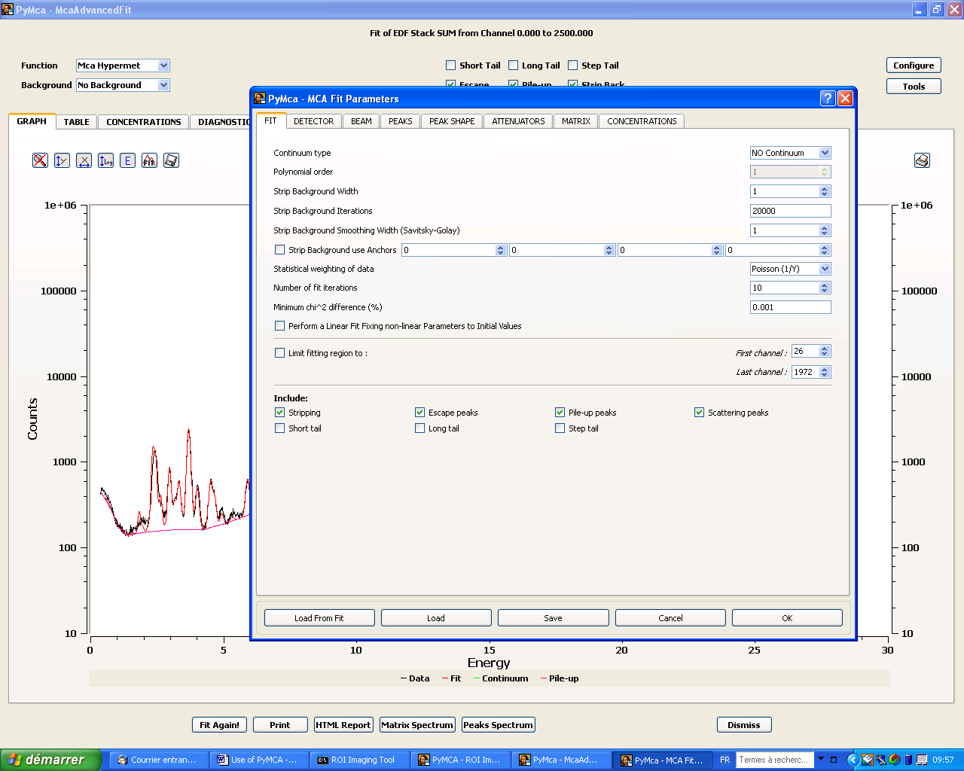

1/ load detector paramaters from fit

2/

* step background iteration = 0

* statistical weight of data = No weight

* perform a linear fit …

Then save this new configuration with a different name (e.g. conf-batch.cfg)

Check that the fit looks good and improve it.

- When the fit is good, you can apply it to all pixels:

Then plugins button< **fast XRF stack fitting**

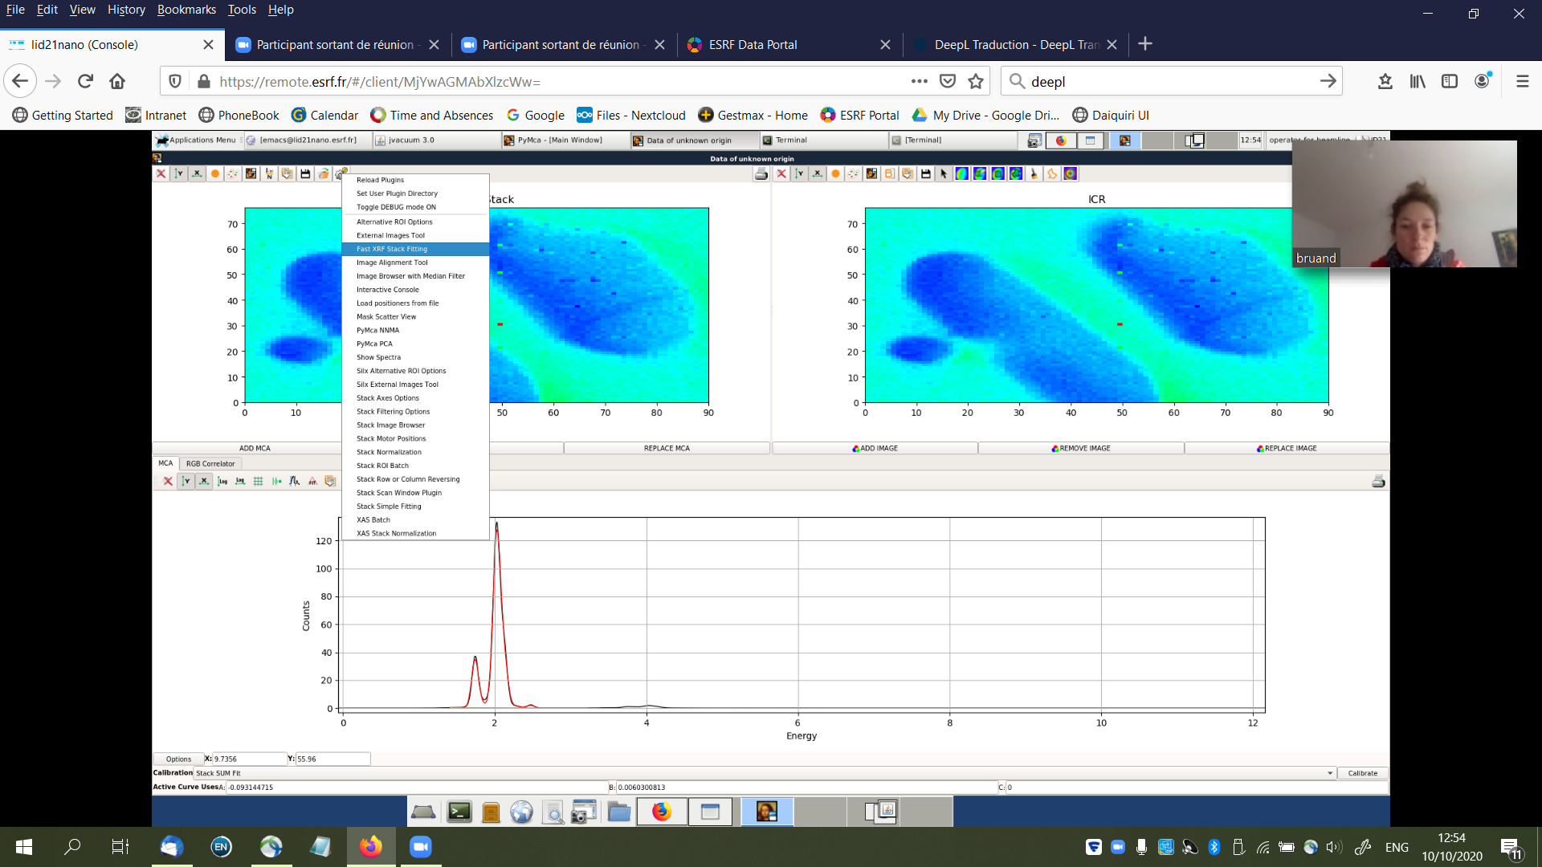

Fill-in the first 3 lines: browse to find the config file, output directory and then give the name of the sample

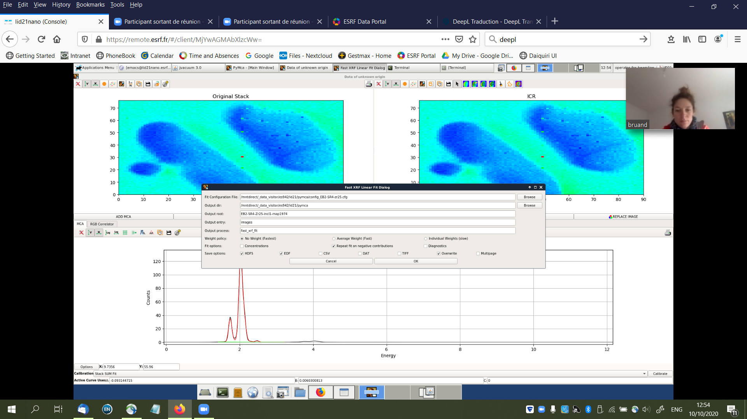

then you should obtain the results as a hdf5. Click on Mona Lisa face to flip the image up side down.

* 1. Opening a previously fitted map

Select Tools<RGB correlator

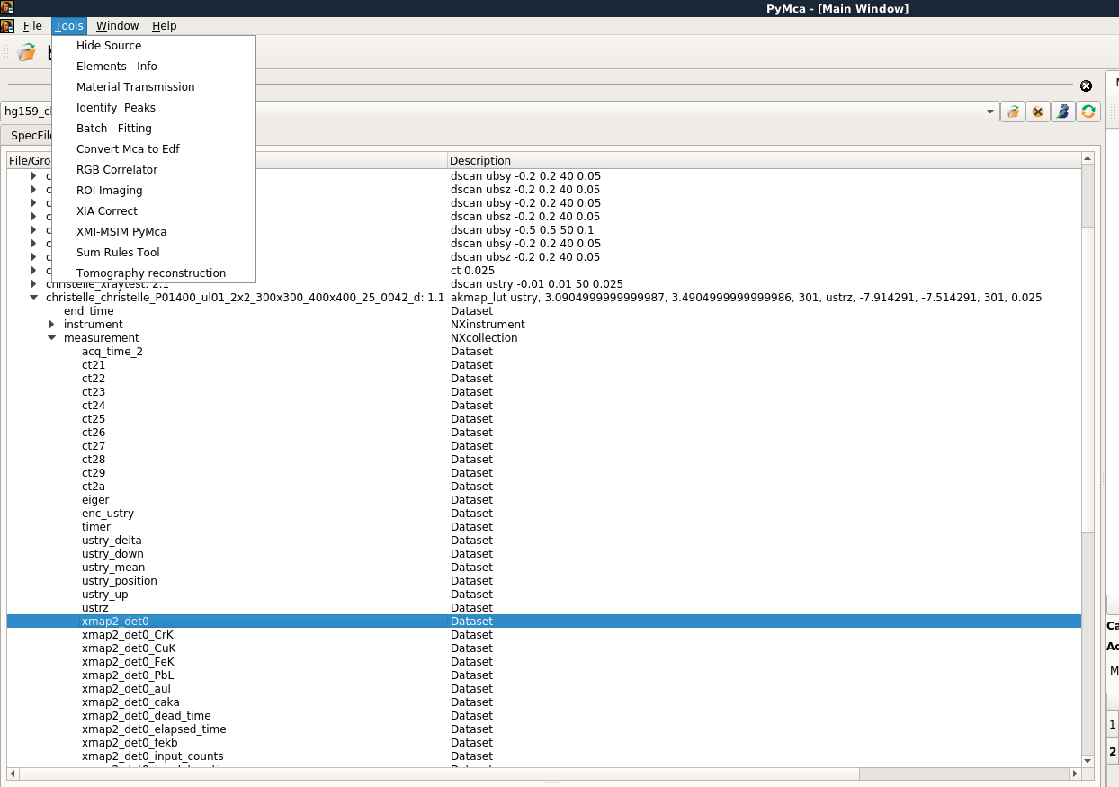

Select “all files” as extension

Choose the .h5 file you want to open

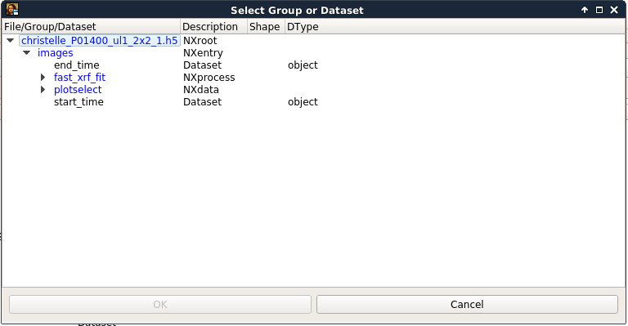

Unroll it until you can double click on “plotselect”

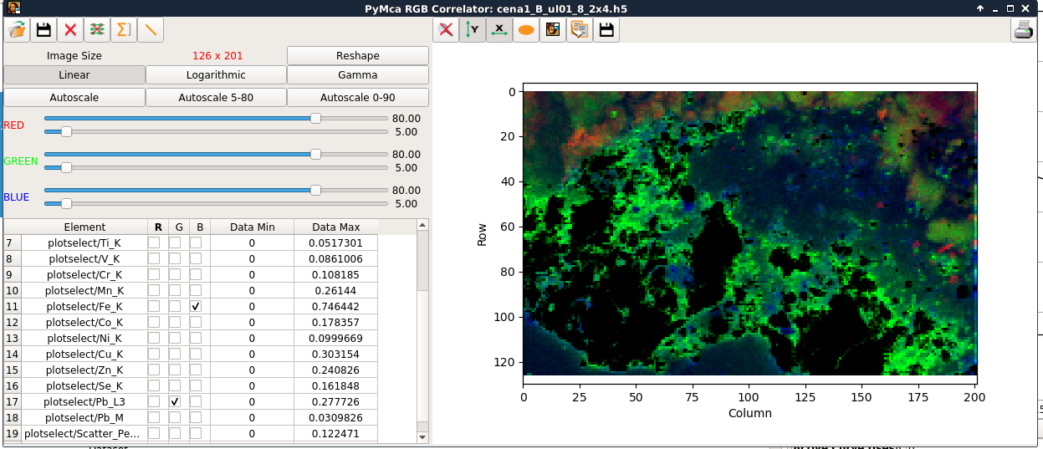

With this tool, you can directly compare the distribution of the various elements (changing the scale if necessary).

Here, I obtain something like that

|  |  |  |  |  |  |  |  |  |  |
| --- | --- | --- | --- | --- | --- | --- | --- | --- | --- |
| E2 | | ag | as | ca | cd | cl | co | cu | fe |
| Map 150×60µm2  Step 1×30µm2 | | Ag | As | Ca | Cd | Cl | Co | Cu | Fe |
|  |  | k | mn | ni | pb | pd | ti |  |  |
|  |  | K | Mn | Ni | Pb | Pd | Ti |  |  |

**2/ X-ray Diffraction data**

The simplest way is to use the same ROI Imaging to open diffraction data

Select Tools<ROI Imaging

select one of the files



Select “hdf5 files”as the extension and choose the map you want to open

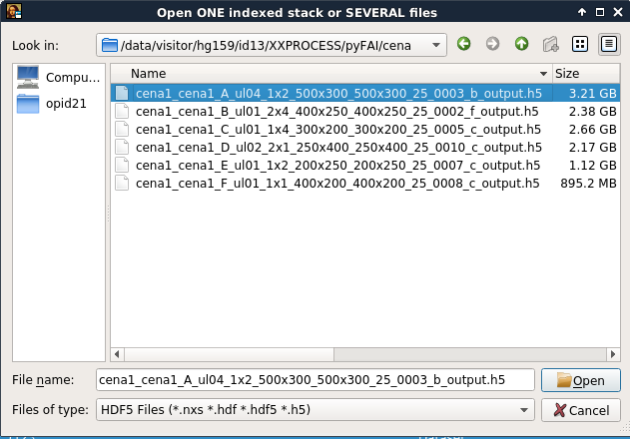

open the hdf5 with roiimaging

unroll the file until "integration_map" and double click on data and twotheta

select data as signals and towtheta as axes, 1D as last dimension, and finish

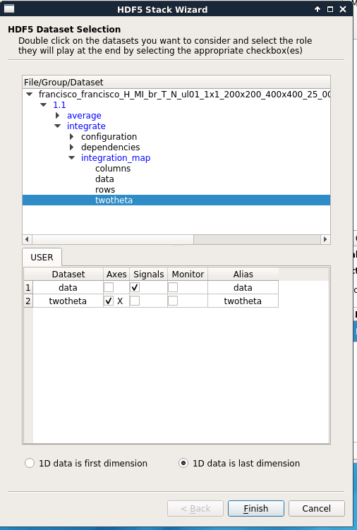

Same display as for fluorescence data.

There are two possibilities for background correction. The correction can be applied

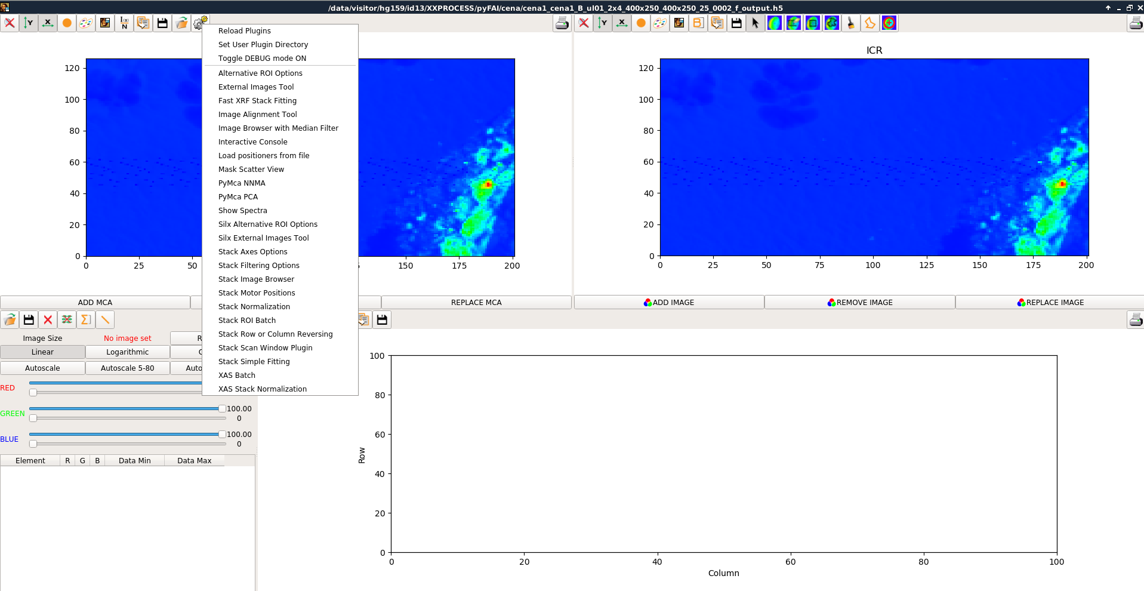

- During ROI calculations (ROI vs. ROI net), see below (B on the right side).

- Directly on the data (stack filtering options)

It can be efficient to run the background correction on the raw datat set.

Select Stack filtering option (left above), then subtract SNIP 1D background

Here is an example of 1D background:

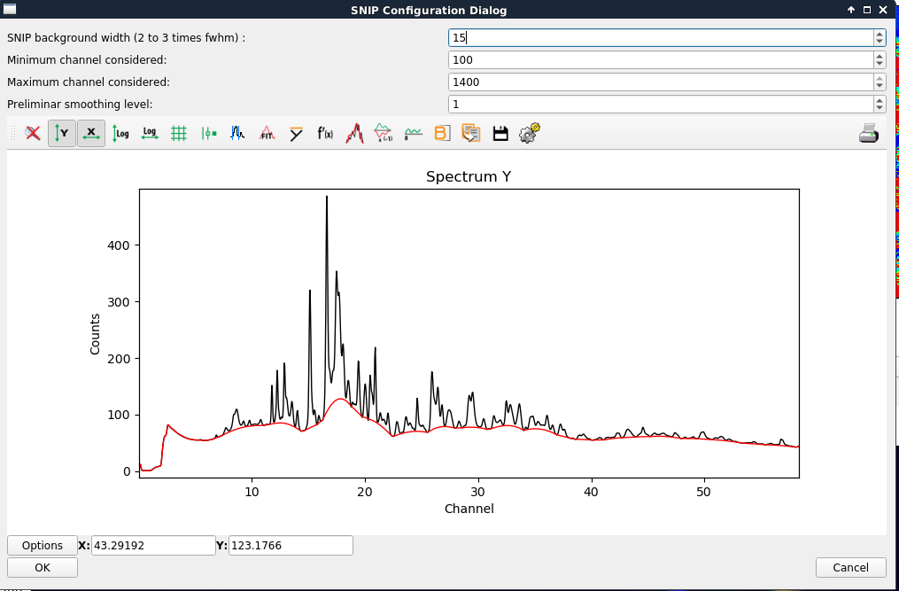

It is recommended to excluded regions at very low and high angles.

Alternatively to ROI images, you can explore PCA and NNMA calculations which can be used to highlight some particular components/ regions over the maps.

Here is an example of NNMA aanlyses:

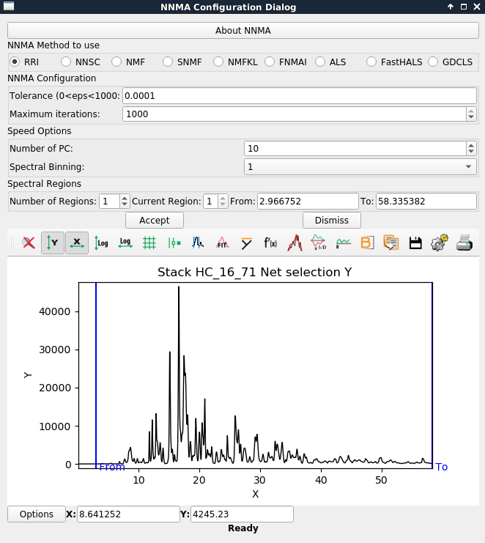

# Combination XRD/XRF

If you want to use XRF maps to find regions of intert to analyse XRD you should:

* Open the XRD maps with ROI Imaging
* Select the fitted XRF maps via tools<external image tools



The selectin tools in the pop-up window will be applied simultaneously to the map in the main ROI imaging window

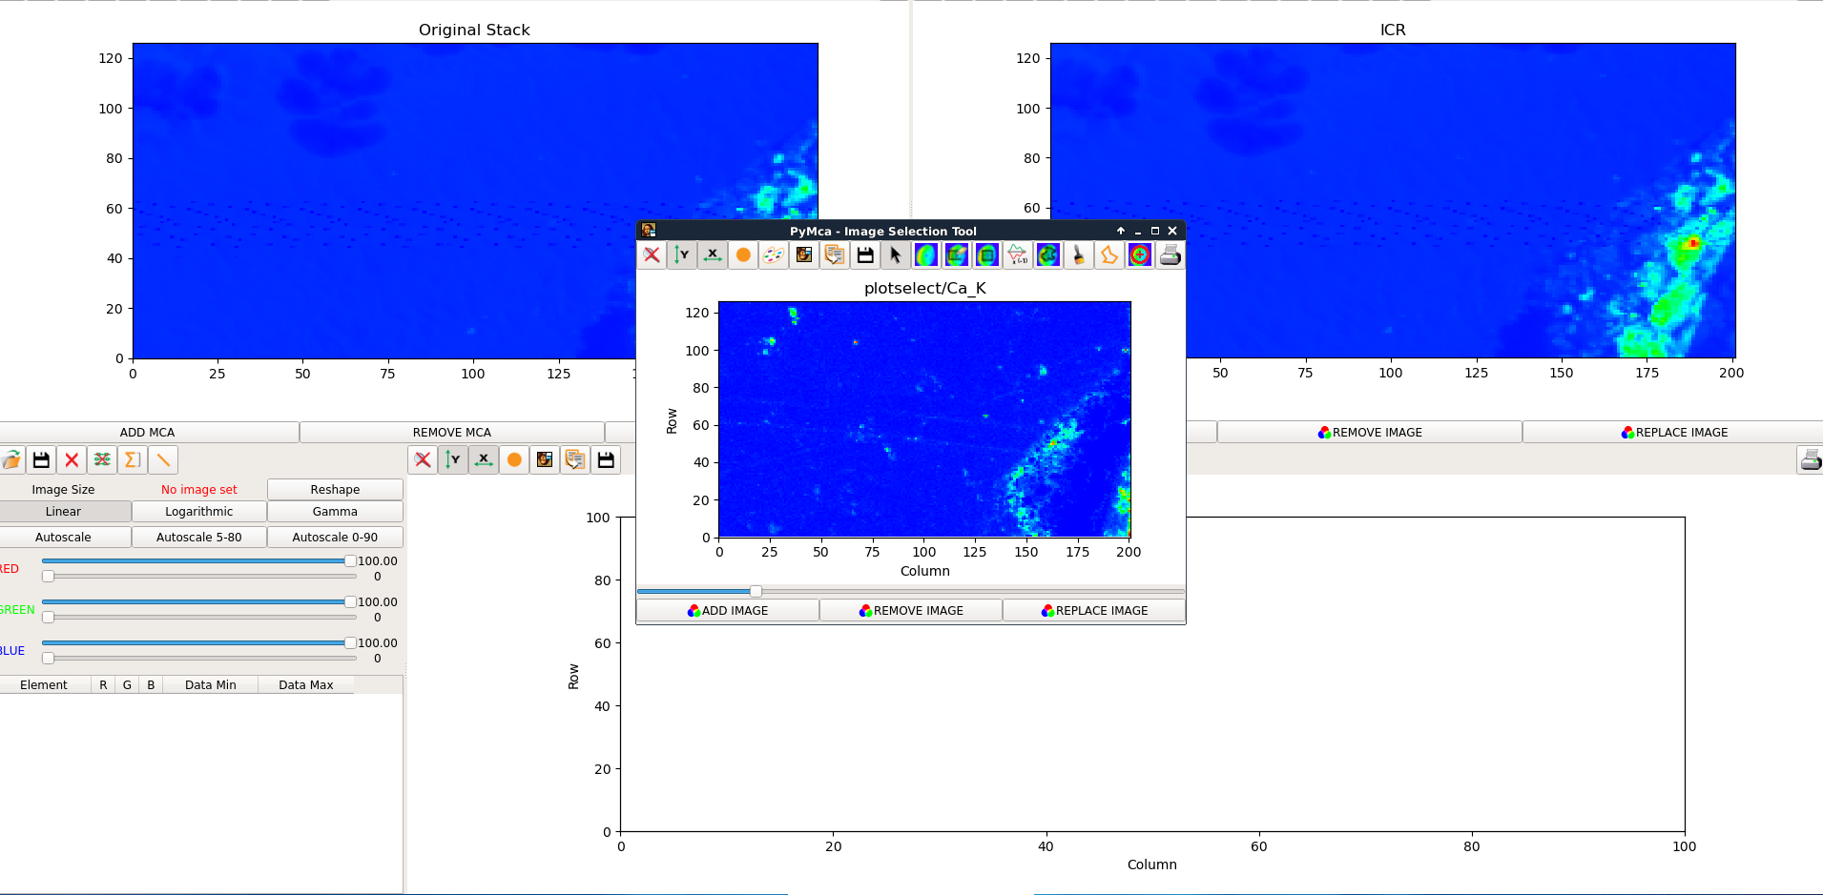

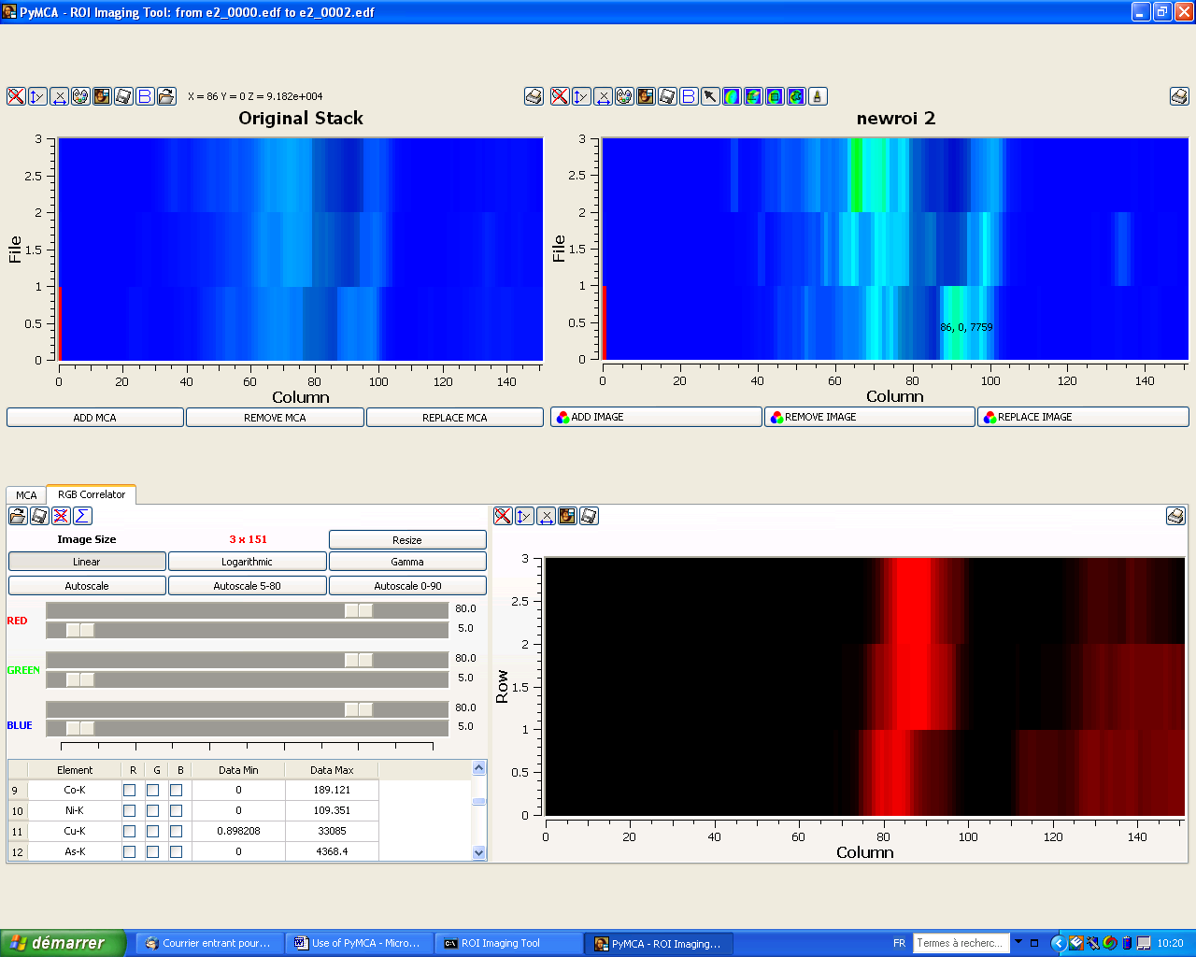

select the brush size

then draw on the map the ROI (following the image seen in RGB)

then calculate the corresponding “MCA”

You can **save** the diffraction result and open it in another software (for example, I use Eva, but files must first be formatted to be read)

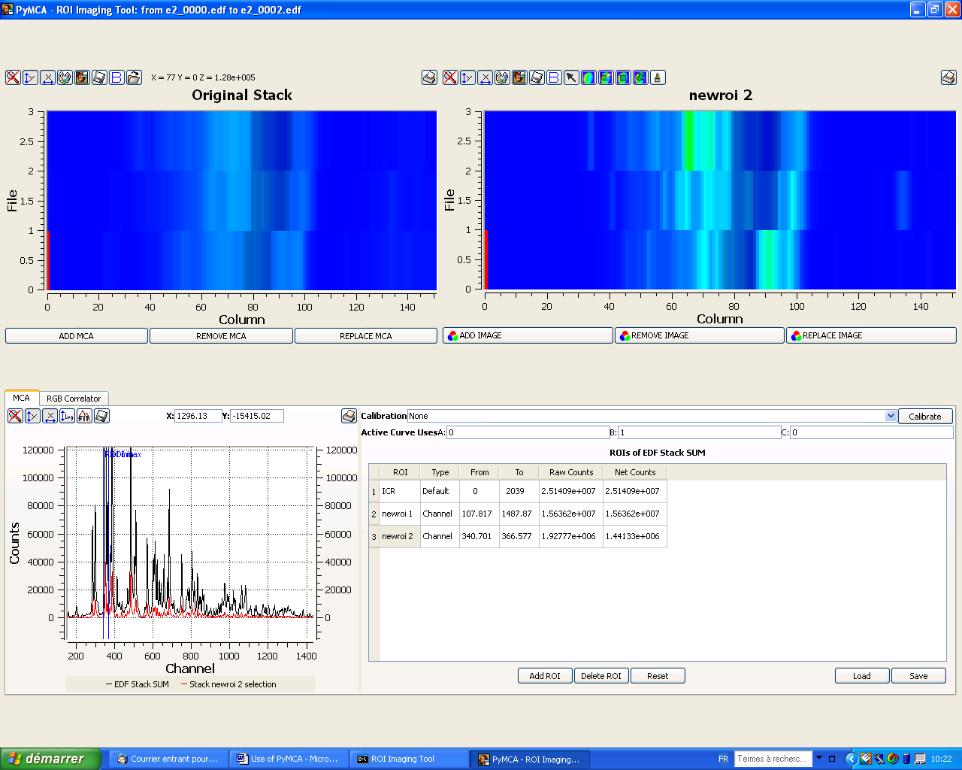

Calculated sum pattern

You can also directly use PyMCA if you search the distribution of a precise phase.

PLEASE NOTE THAT EXAMPLES BELOW ARE FROM A PREVIOUS EXPERIMENT, NOT HG159

Then you can follow the distribution of a phase providing that you know one of characteristic peak without interference with another phase.

For example, with Eva I obtain a fit of the Pb layer diffraction pattern



The peak at theta= 3.85° is characteristic of hydrocerussite, without few interference from cerussite, so I can map hydrocerussite:¨

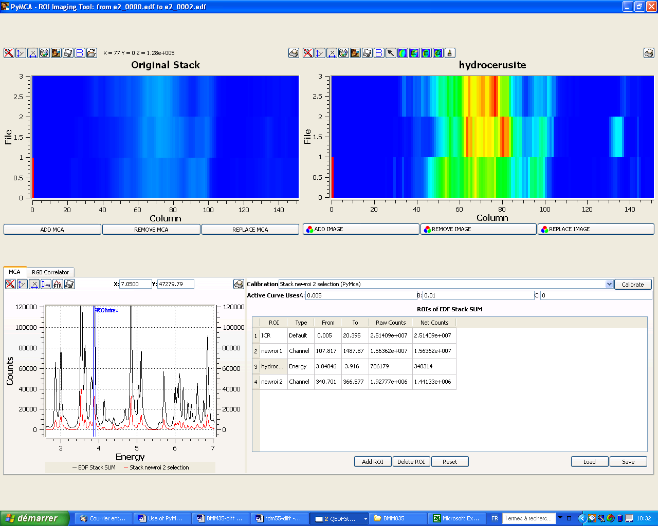

The peak at 3.63° is characteristic of cerussite

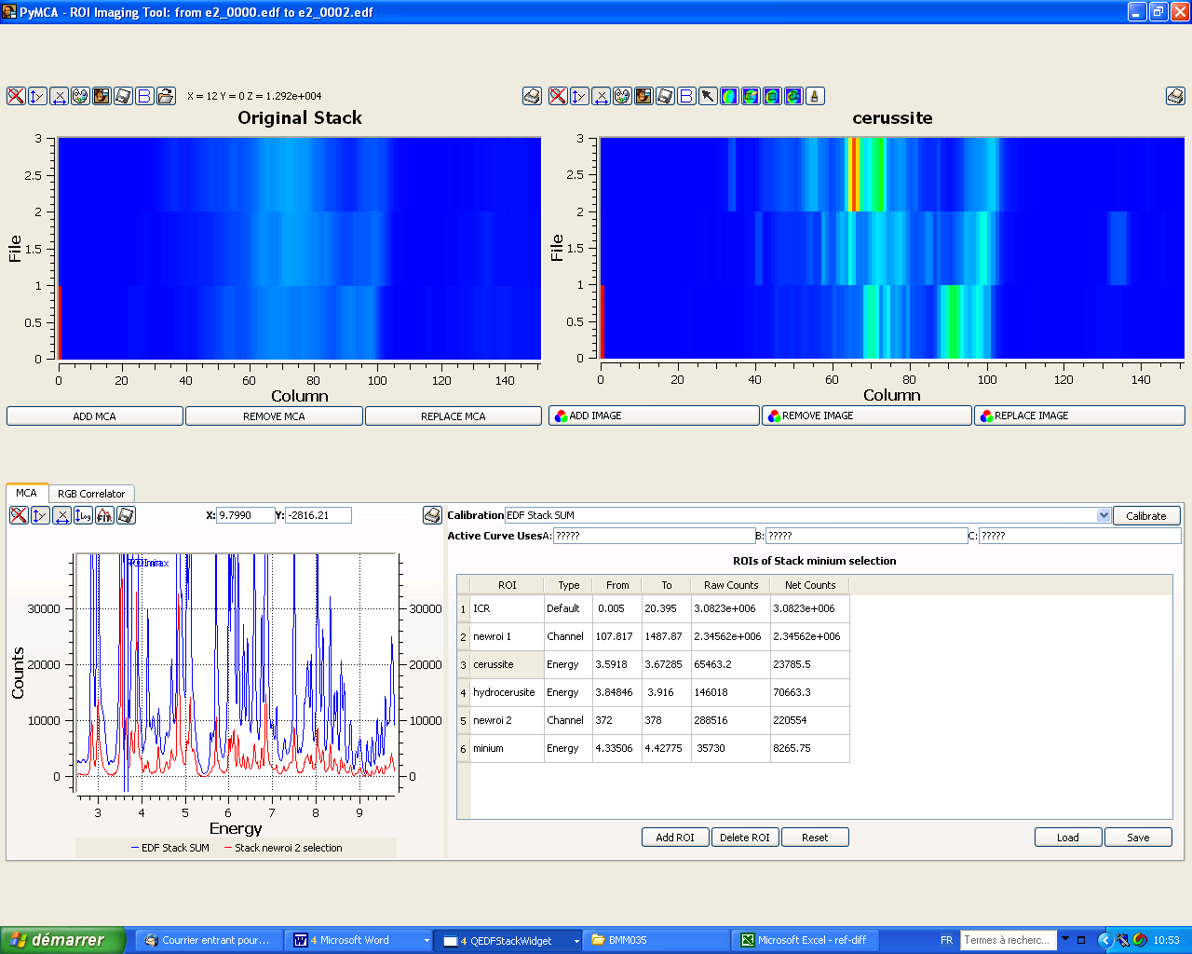

Minium can be seen with this peak:



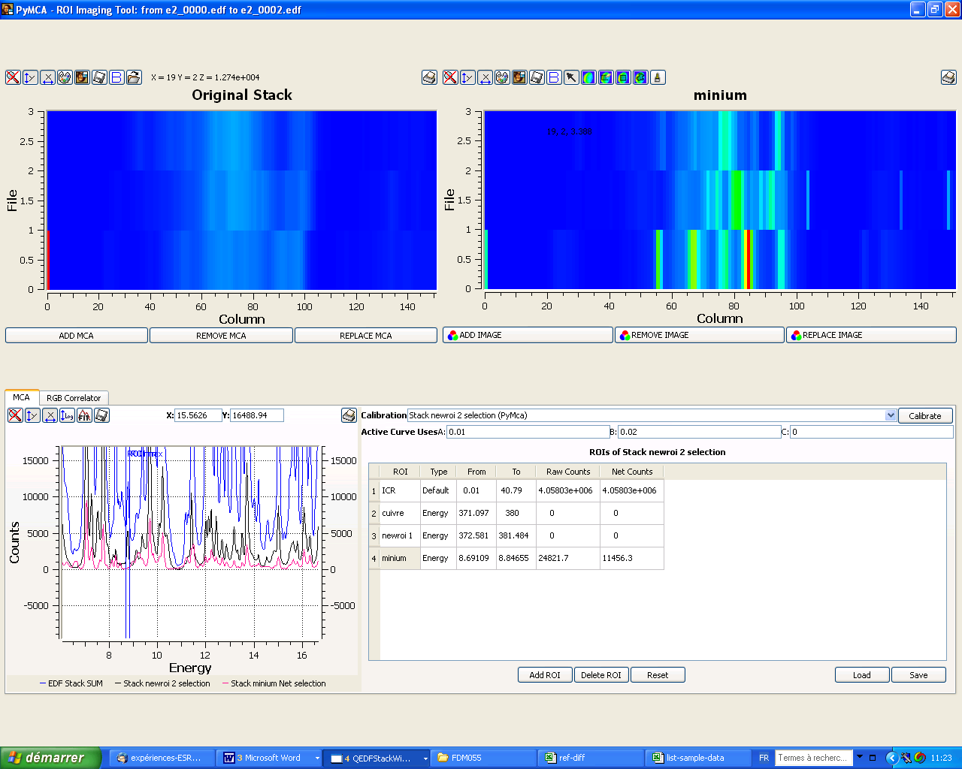

A second peak is interesting:



The problem is that gives a huge interference in this region with quartz



By choosing an appropriate ROI it is possible to get minium (if needed use the background correction on map, see below).

* 1. Background correction during ROI calculation

Instead of applying a background correction directly to the data, it is possible to apply such a correction during the ROI calculation.

The principle is that the signal intensity is integrated only above a line passing by the 2 points on the pattern at the ROI min and max values.

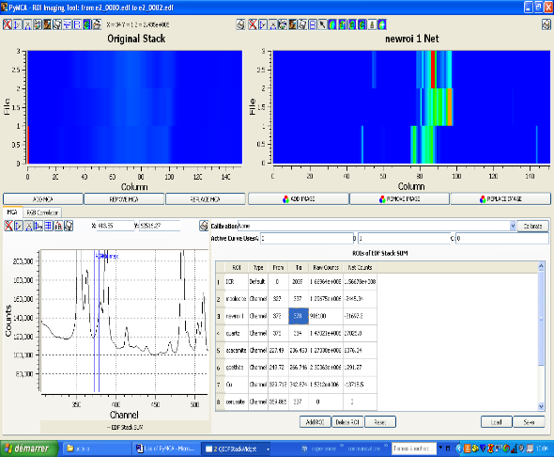 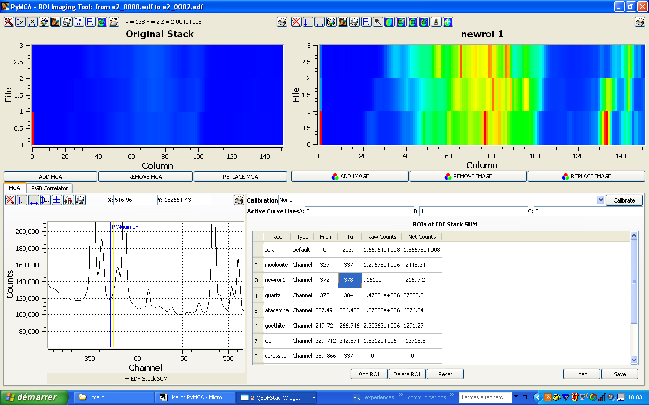

quartz

Same ROI but with and without the background correction (B)

Note that the map name now contains the word “Net”, which indicates that B correction was applied during calculation.

The same way, it is possible to get atacamite map event with the huge background under the small peak

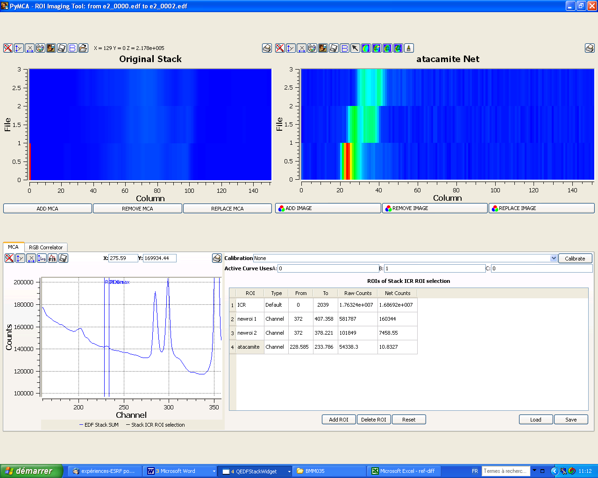

Finally, RGB tool enable to compare elemental and phase maps:

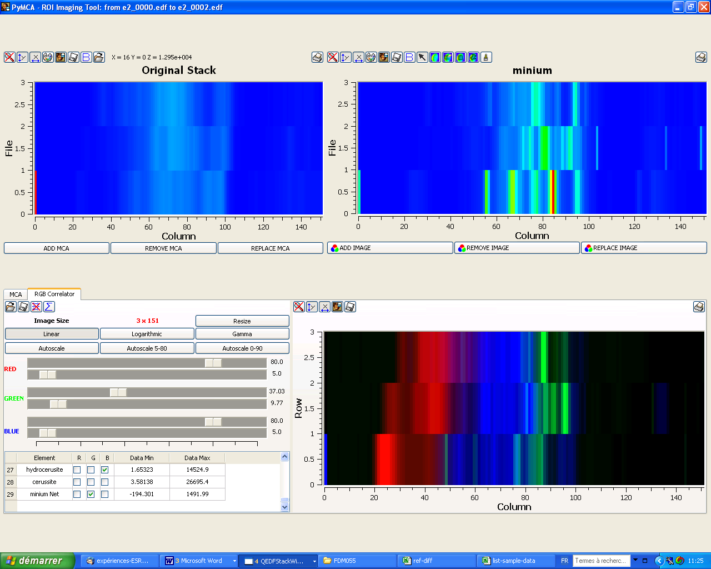

Here= Cu, hydrocerussite and minium

**3/ Crossed treatment of X-ray Fluorescence and X-ray Diffraction data**

It is possible to open and to treat into 2 parallel windows the XRF and XRD data.

Open one of the sets of data (here XRF).

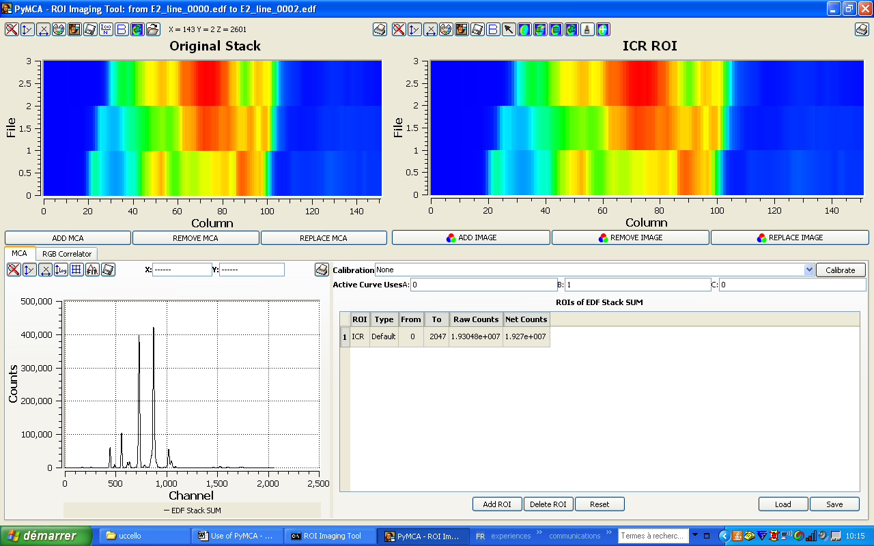

Then, use the “open” tool to open the second set of data (here XRD). This action is limited to acquisitions which have the same size (same numbers of pixel, in both directions). It can be any hyper spectral data.

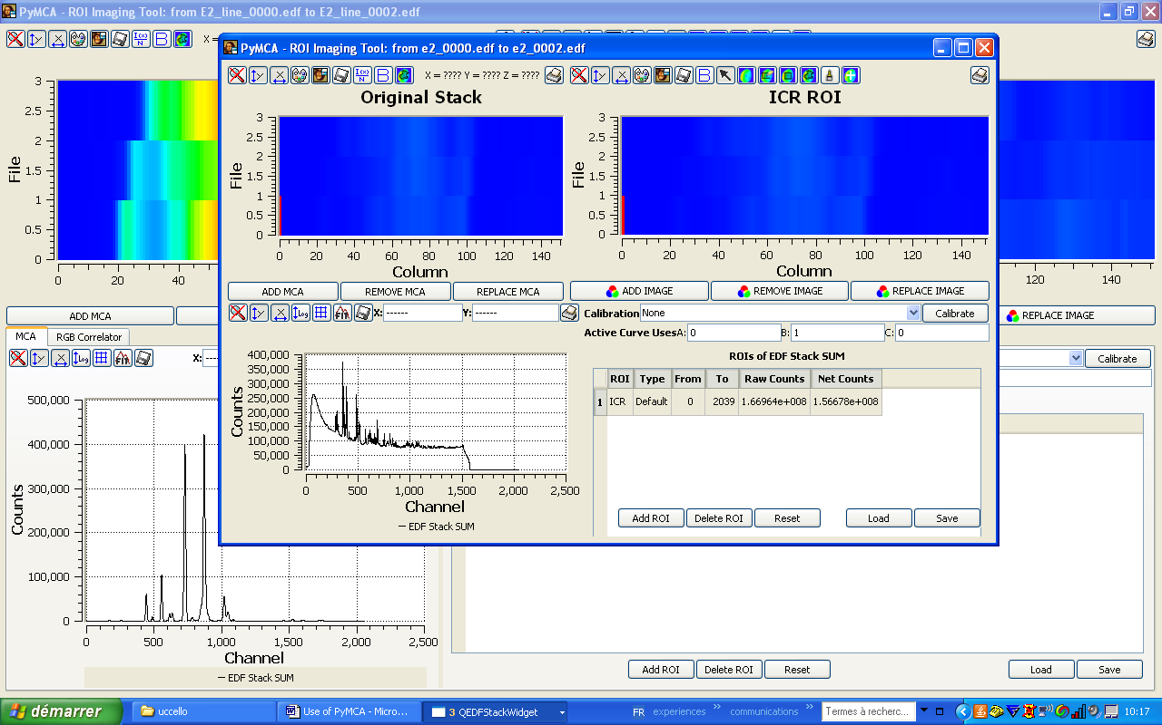

There are now 2 superimposed windows: one with XRF data, one with XRD data.

Example of application to treat XRD data by exploiting XRF maps:

In the XRF window:

1. in the RGB sub-window, open the .dat file obtained with the batch fitting

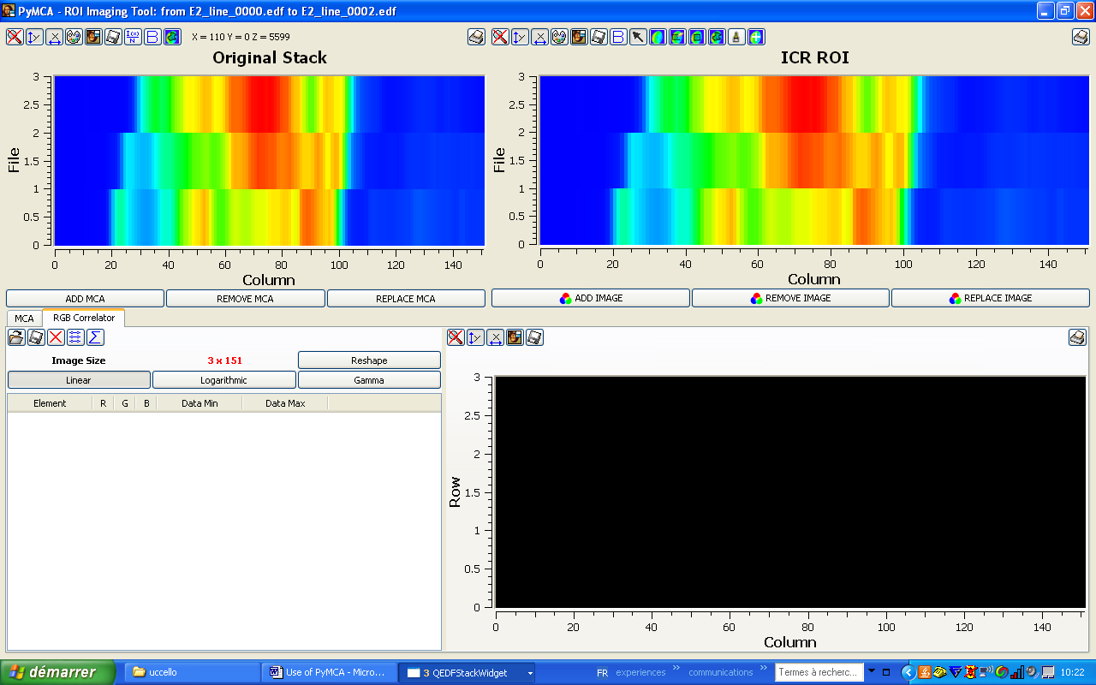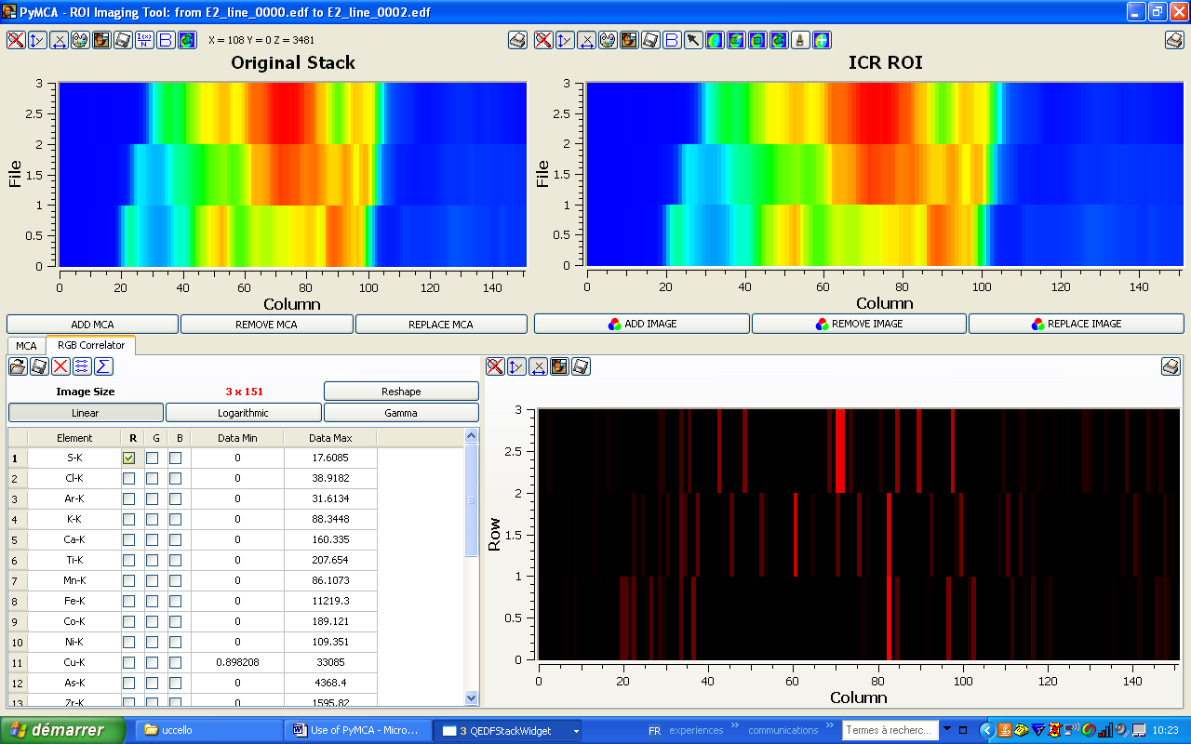

Search a relevant element which has an interesting distribution (here Cu)

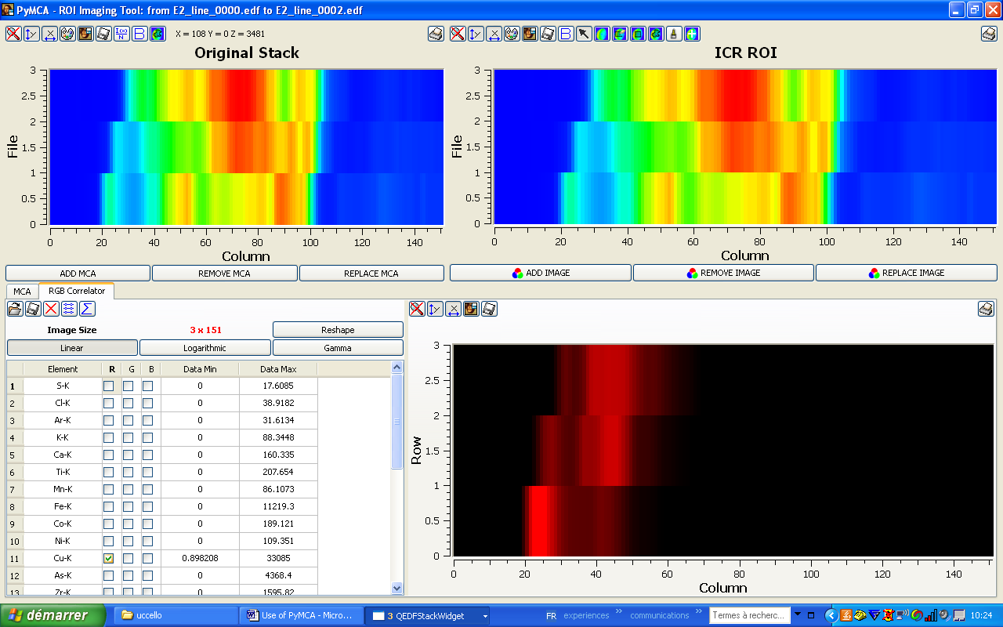

Come back to the MCA sub-window, and in the ROI list, put the corresponding ROI

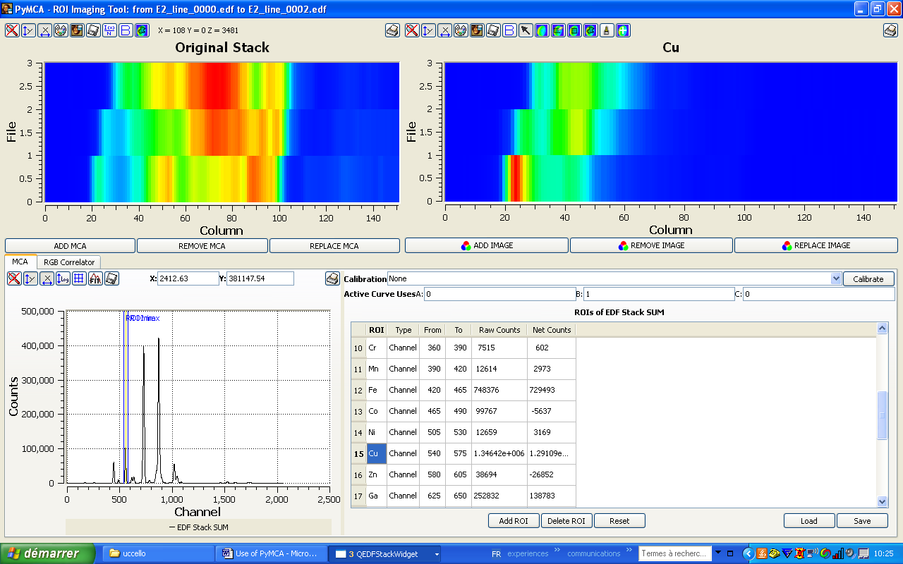

The interesting ma p is now in the active ROI image window

Use the brush tool (or the selection tool) to select the pixels corresponding to this layer (the grey scale enables a better readability).

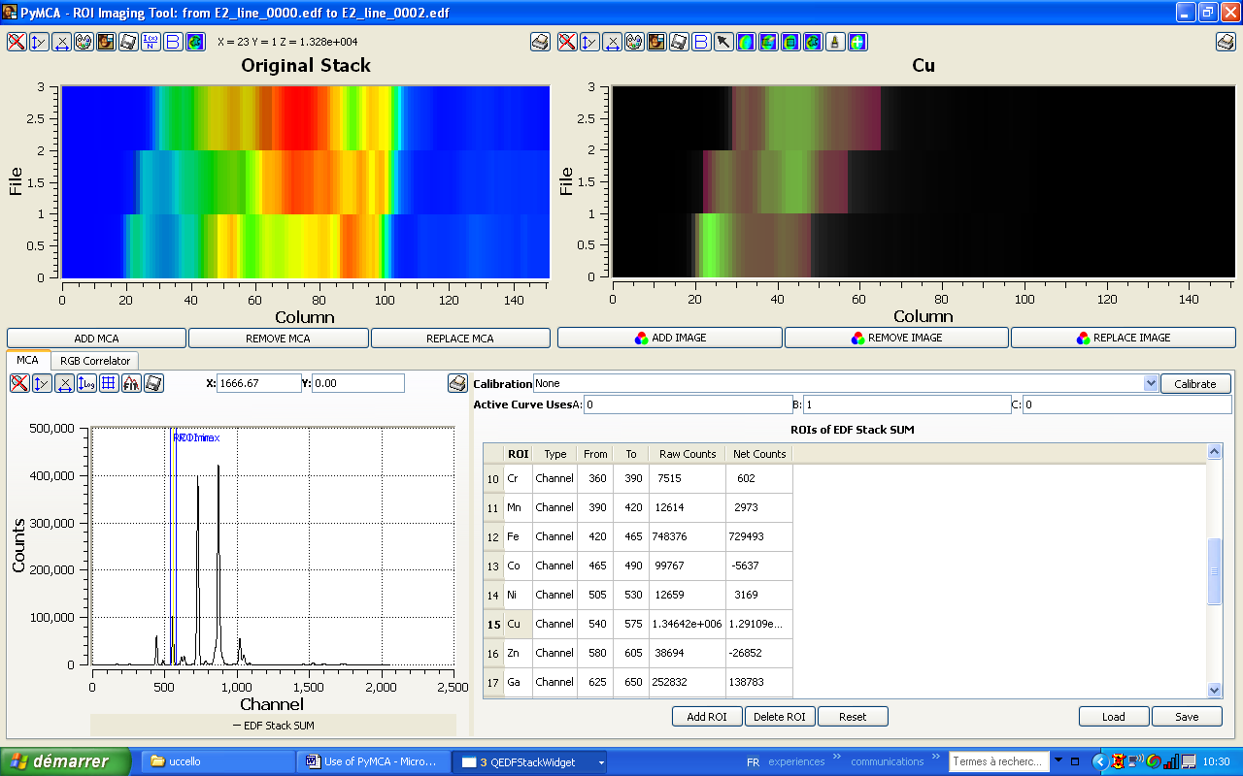

If you come back to the XRD window, you see that the same region has been selected simultaneously.

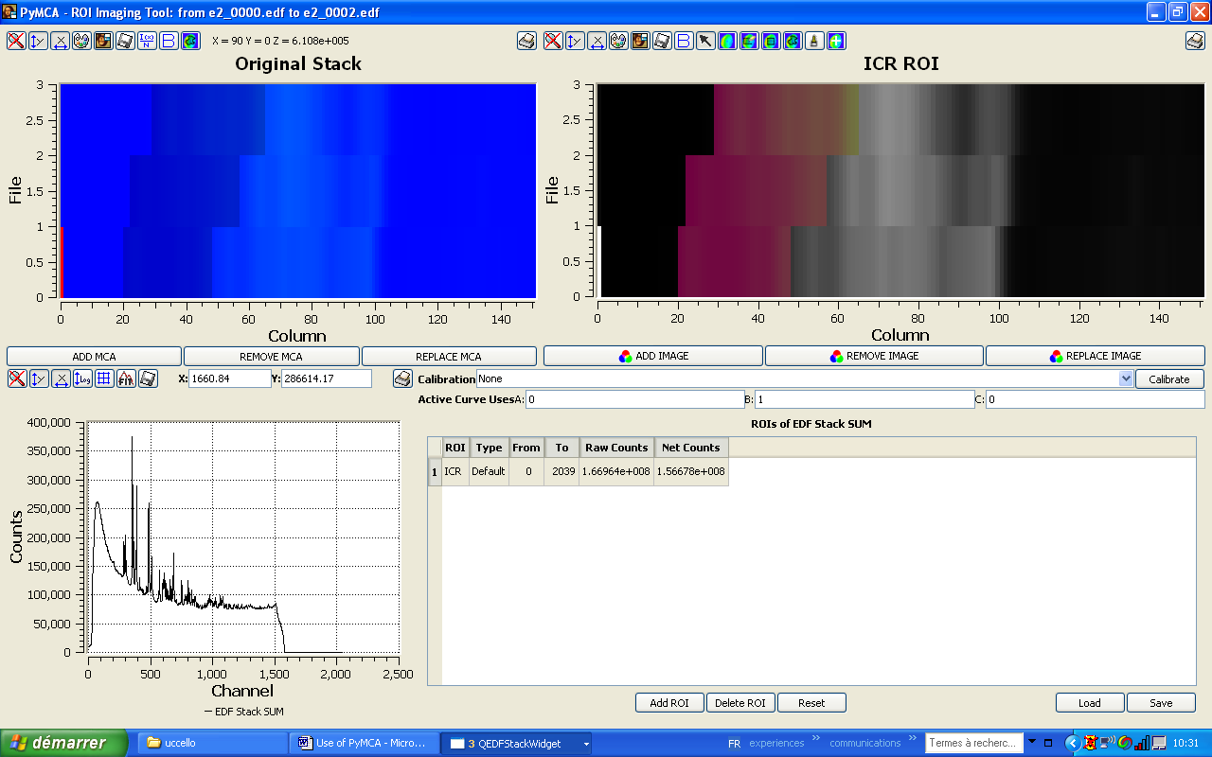

In both windows, you can calculate the corresponding sum (or average) XRF spectrum and XRD pattern (click on “ADD MCA” in both windows).

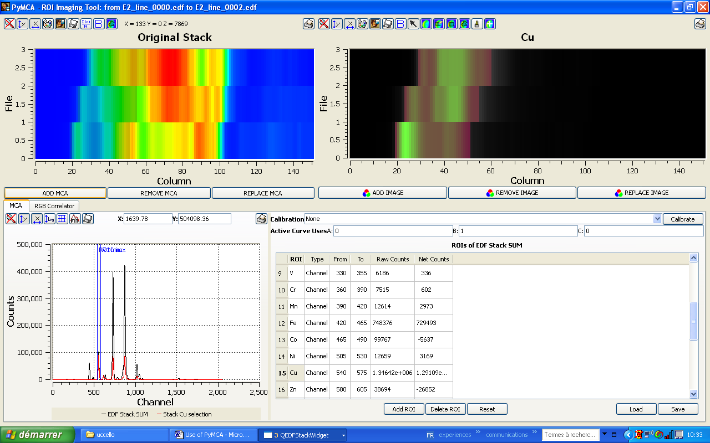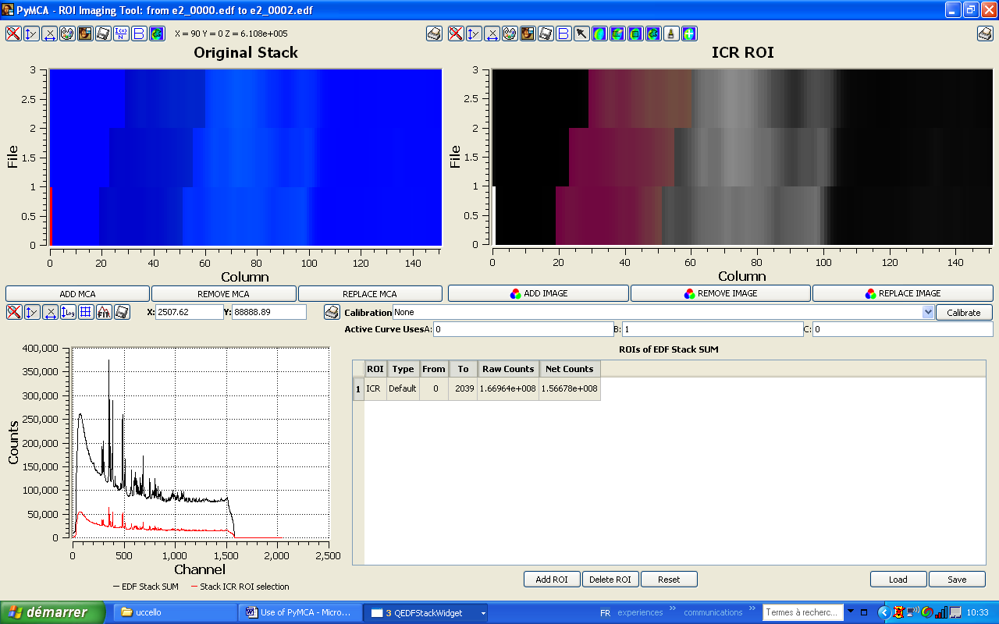

The further treatment is the same as before. The advantage is that the treatment is localised in exactly the same region, for both sets of data.