Azimuthal integration workflow for

2D XRD mapping at ID13
Azimuthal data integration can be performed through the Juno project provided by Loïc Huder (ESRF). This project makes use of jupyter notebooks that can be run individually and independently by users to azimuthally integrate 2D XRD data. A large part of the workflow given here has been adapted from the documentation of Loïc Huder which is available at https://gitlab.esrf.fr/loic.huder/juno and https://gitlab.esrf.fr/loic.huder/juno/-/blob/main/Using_notebooks.ipynb

Contents
1. Start up your Juno environment 2
2. First time only! 4
3. Upload/Create run_config.yml file 5
3.1. Upload a run_config.yml file 5
3.2. Create a new run_config.yml file 6
4. Set parameters in run_config.yml 8
4.1. Finding the input_file (path and name of your dataset) 11
4.2. Common mistakes 13
5. Run integration in 2a_integration_maps.ipynb 14
5.1. Integrate a single data set 14
5.2. Optional 19
6. Transfer and download your data 21
7. Update Juno 22

Start up your Juno environment
Go to jupyter-slurm or https://jupyter-slurm.esrf.fr/hub/spawn and login with your ESRF account.
Connect to a session and request a node on the jupyter-p9gpu partition with a GPU.
- Select IBM Power9 in the Partition section
- Select Minimum (1 core) in the CPUs section
- Select 1 in the GPUs section
- Change the job duration to a higher number if you are processing multiple datasets
- Press Start
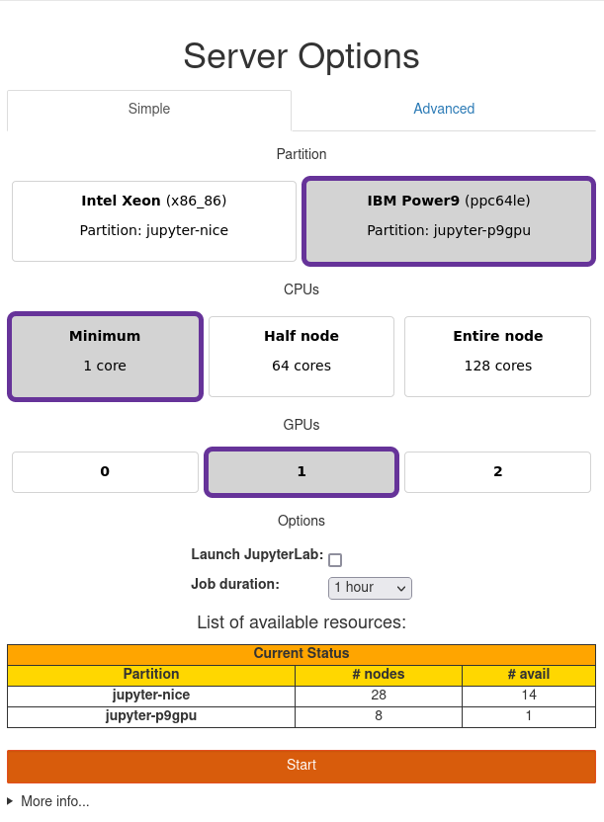
This will take you to a loading screen …
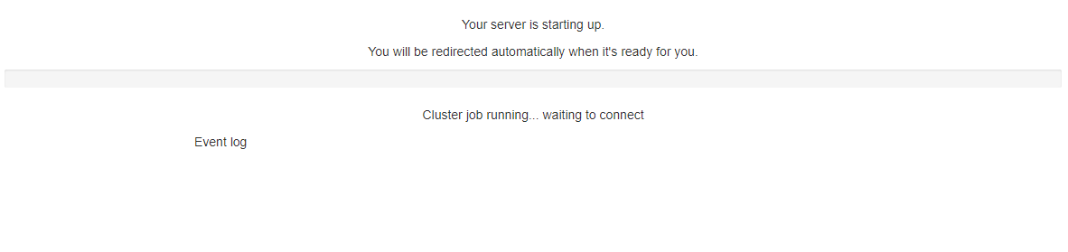
… and after some seconds a new page will open. We will name this new page the Project window.
In the Project window, open a terminal.
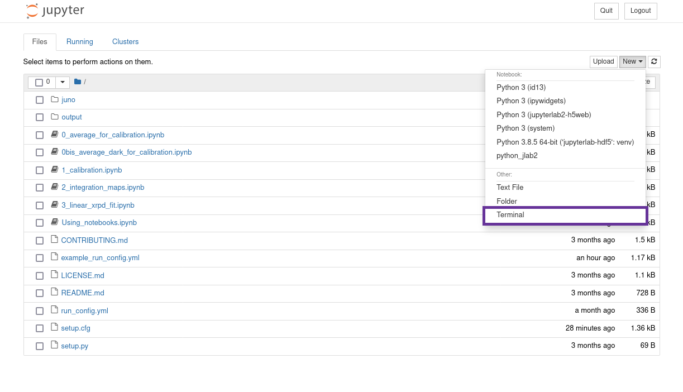
This will open a new window with your terminal. We will name this the Terminal window. You will need to work in both windows during the rest of the workflow, so do not close these.

First time only!
Only when you started your session for the first time, you need to copy the juno project to your personal session. Anything that you change here is only for you and will not affect other users. After you close your session and start again from ‘Start up your Juno environment’ you do not need to repeat the steps below.
To copy the juno folder, go to the Terminal window and run the following command
>> git clone https://gitlab.esrf.fr/loic.huder/juno
This will create a juno folder containing the notebooks and all the project files. In your Project window a new folder juno should have been created.
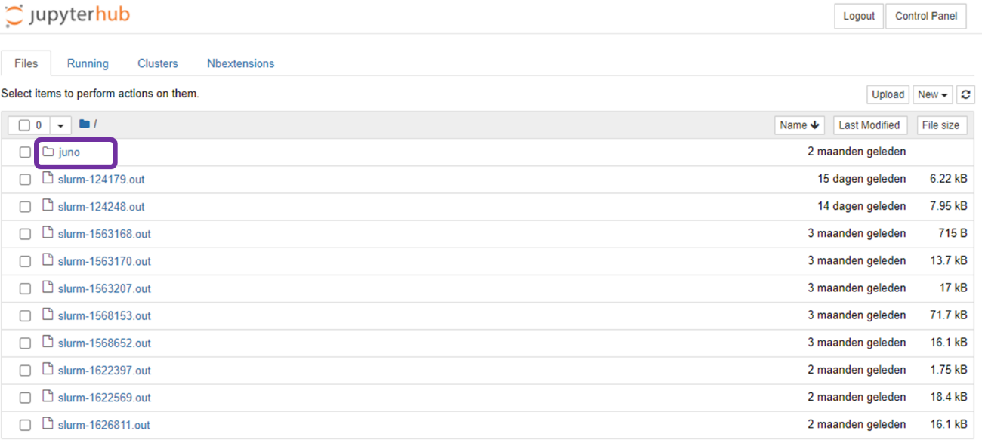
If you click on the juno folder in your Project window, you will be able to see all the project files.
it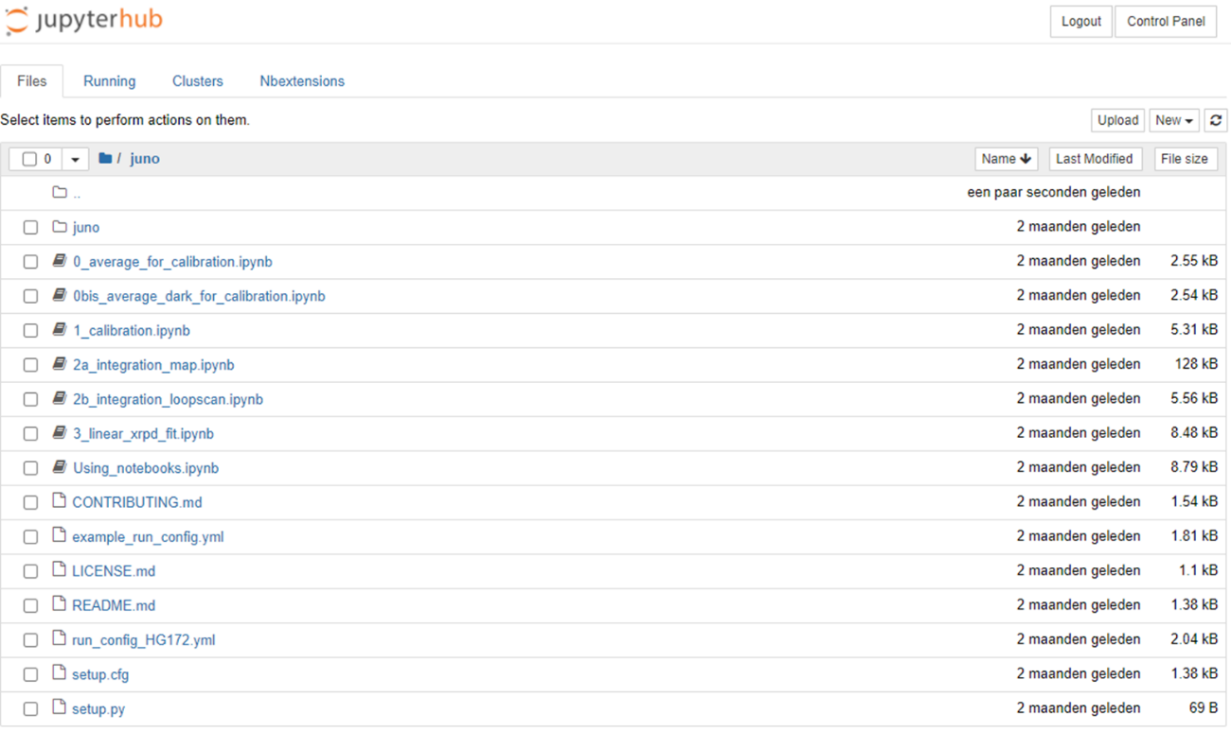

Upload/Create run_config.yml file
The run_config.yml file contains several parameters for the data integration and will be needed in the next steps. In this step you will learn how to upload an existing file to your juno folder (3.1) or how to create a new config file (3.2).

Upload a run_config.yml file
If you have received a run_config.yml file (from the RSs) that is specific for your beamtime, you can upload it to your juno folder through the Project window. You can then use this config file for section 4 in this workflow. Typically a run_config.yml file will have been created during the experiment in the XXPROCESS_jupyter folder (/data/visitor/hg172/id13/XXPROCESS_jupyter) and will have been uploaded to the Heritage BAG cloud space.
In the Project window, click on Upload and select the config file in the pop-up window.
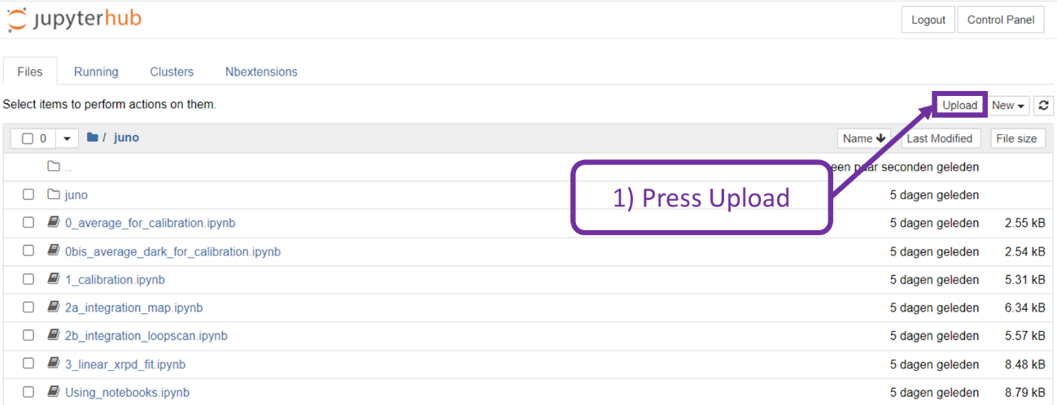
In the example below, the run_config_test.yml was selected in the pop-up window. Check to make sure that you selected the correct file and press the new blue Upload button. The new config file should now have been added to your juno folder.
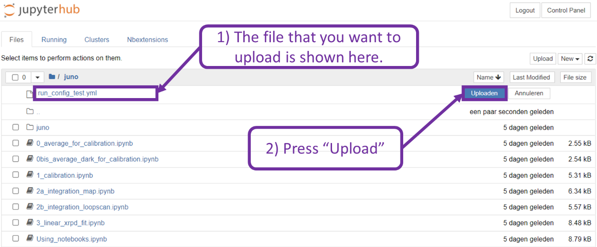

Create a new run_config.yml file
The easiest way to create the run_config.yml file is by copying an existing/old run_config.yml file and renaming it. In this example, the existing file example_run_config.yml will be copied and the copy will be renamed to run_config.yml. There are two ways to copy and rename this file.
You can do this in the Project window. In the Project window, click on the checkbox in front of example_run_config.yml and press duplicate. This will open a pop-up window that will ask you to confirm. The filename of the copied file will be the same as the original to which “-Copy1” has been appended.
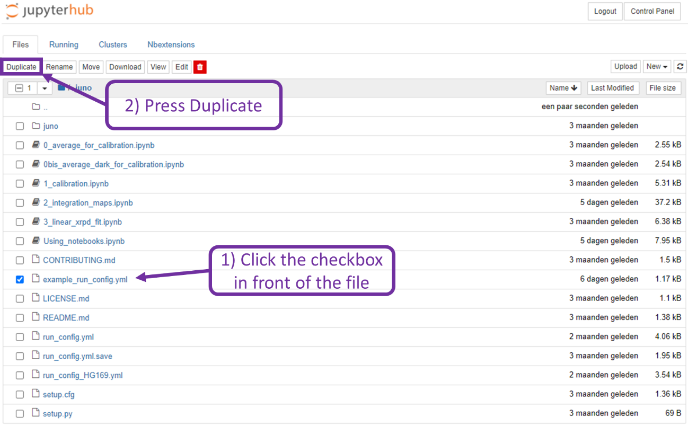
After this, click on the checkbox in front of the copied file and press rename. This will open a new pop-up window where you can give the new filename. It might be a good practice to include the experiment number to this filename (e.g., run_config_HG159.yml) since more run_config files will start to appear as more experiments pass.
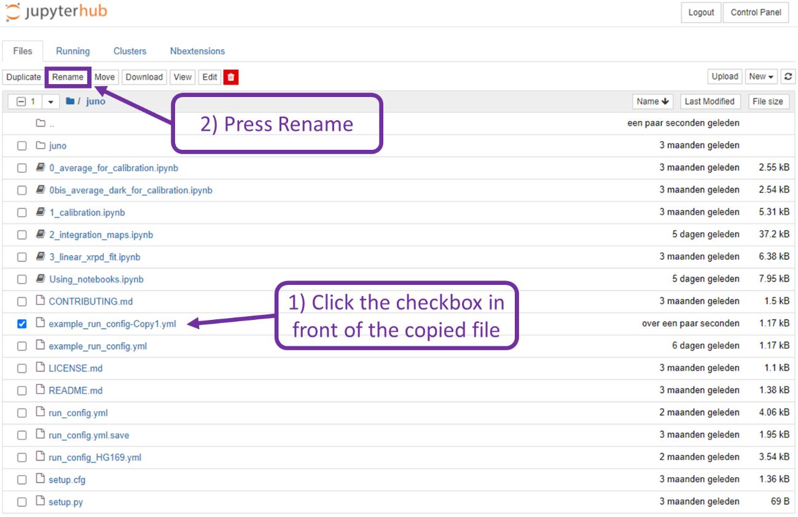

Alternatively, you can copy and rename example_run_config.yml in the Terminal window that you opened earlier.
In the Terminal window, first go to the juno folder
>> cd juno
Second, copy and rename the file example_run_config.yml
>> cp example_run_config.yml ./run_config.yml

Congratulations! Your Juno environment and project has been set up and you can start the next steps in the data integration workflow!

Set parameters in run_config.yml
In the file run_config.yml you need to set several parameters to perform the integration. You mainly need to specify the folders that contain the data and the folders to which the data needs to be saved as well as the dataset that you want to process.
In your Project window, click on the run_config.yml file that you uploaded (section 3.1) or created (section 3.2) previously. This will open a new window with a color formatted text file that you can edit.
In this file the following color format is used
- The text in green starts with the symbol #. These are comments that provide you with more information but do not affect the integration.
- The text in blue are parameters that are called within the notebooks. Do not change these!
- The text in red are strings that you can change.
You only need to change (some of) the text that is shown in red.

The proposal_folder should specify the folder that contains your datasets. Typically all data is stored in the main directory of ID13. The name of the datasets start with the initials of the proposer (e.g., FV_dataset1 for the first dataset of Frederik Vanmeert). If you do not know the name of the folder that contains your data or the name of your dataset, see section 4.1.
proposal_folder: “/data/visitor/hg172/id13”
The output folder is where the integrated data will be saved. All processed files that are created using the Jupyter notebooks should be stored in the XXPROCESS_jupyter folder.
output_folder: “/data/visitor/hg172/id13/XXPROCESS_jupyter”
e.g., output_folder: “/data/visitor/hg172/id13/XXPROCESS_jupyter”

You should not change things in the sections average, dark and calibration. These have already been set for you if you uploaded the file from the RSs.

In the section integration, you need to specify the path and file name of your dataset and the file name that needs to be given to your integrated data. The paths are relative to the paths of the proposal_folder and output_folder that you specified earlier, respectively for the input_file and output_file. You do not need to change the mask_file if you uploaded the file from the RSs.
input_file: “your_sample/your_dataset/your_dataset.h5”
e.g., input_file: “FV_test/FV_test_dataset/FV_test_dataset.h5”

output_file: “INITIALS/your_dataset_output.h5”
e.g., output_file: “FV/FV_test_dataset_output.h5”
Go to File -> Save to save your run_config.yml file.
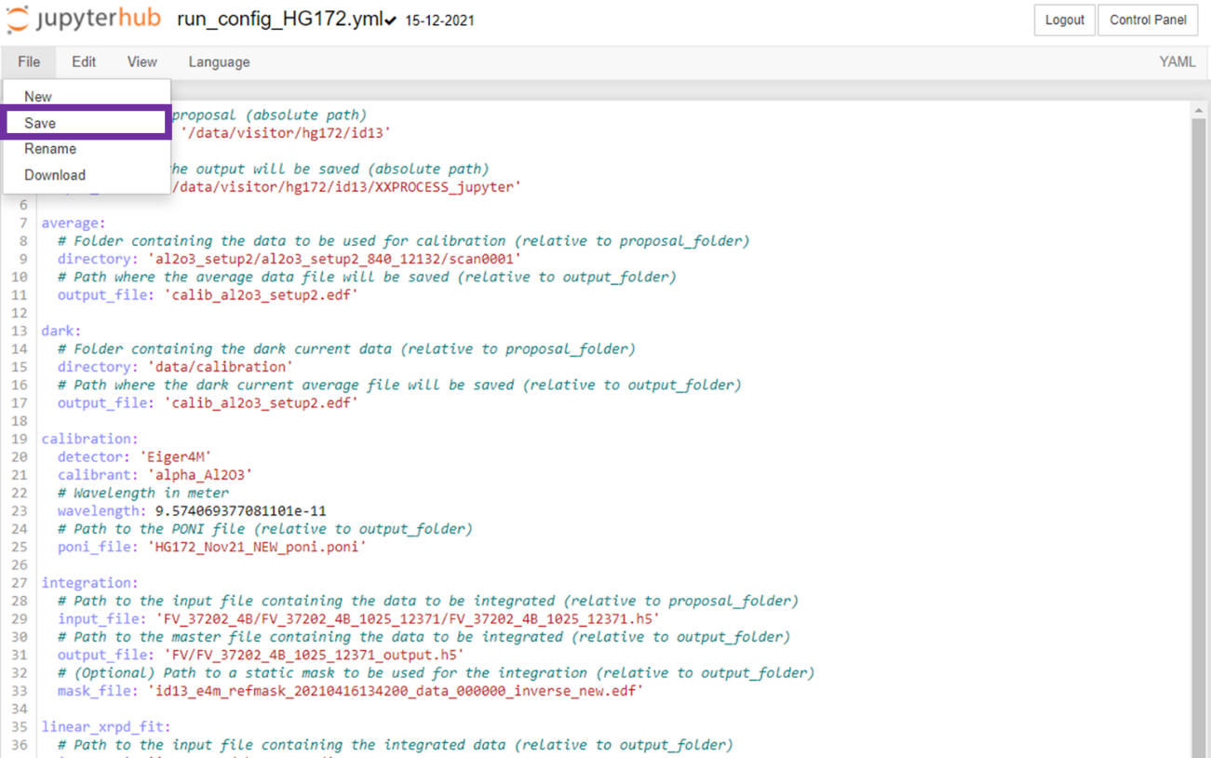
Be sure that all parameters are properly set as the whole config will be tested at each step!
Your final configuration file should look like this.
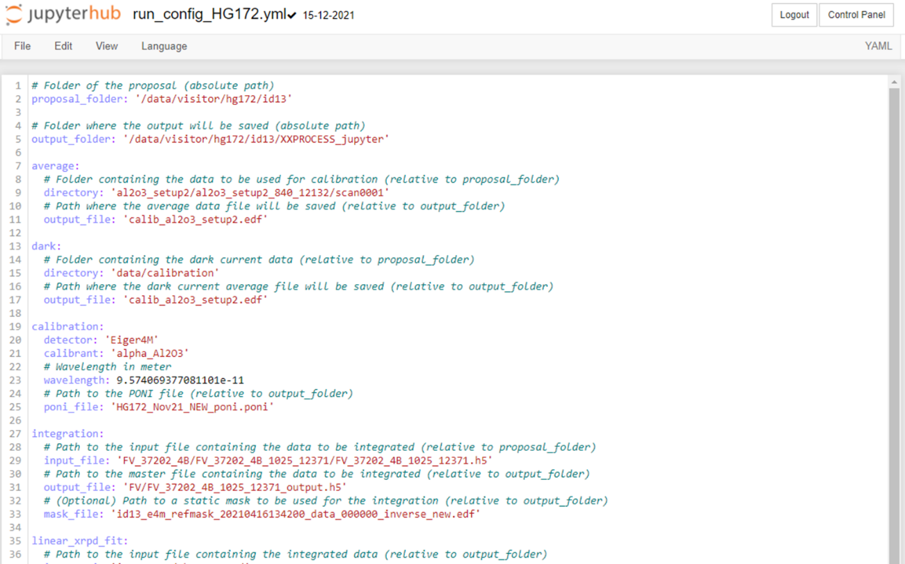

To keep things organized your data will be stored in a folder with your initials (as set as the output_file in the run_config.yml file). If the folder with your initials does not yet exist within the XXPROCESS_jupyter folder, you first need to create it before proceeding with section 5. You will need to do this in the Terminal window.
In the Terminal window, go to the output_folder that you specified above
>> cd /data/visitor/hg172/id13/XXPROCESS_jupyter
Use the mkdir command to create a folder with your initials inside the output_folder
>> mkdir “your_INITIALS”
e.g., >> mkdir FV
This will create a folder with the name ‘FV’ in the XXPROCESS_jupyter folder. This folder will contain all your processed files after performing the steps in section 5.

Finding the input_file (path and name of your dataset)
During the experiment, unique names and folders are created for each sample and measurement. The naming conventions are the following:
- INITIALS : the initials of the proposer to which the sample belongs
- sample_name : the name of the sample as entered in the cloud wish list
- sample_id : a unique number created by Daiquiri once the sample has been added
- measurement_number : a unique number created by Daiquiri once a scan/measurement has been created
The following folders will be created:
- INITIALS_sample_name : for each sample
  - e.g., FV_test
- INITIALS_sample_name_sample_id_measurement_number : for each measurement
  - e.g., FV_test_830_10904

If you do not know where your datasets are stored (i.e., you do not know what to put for the input_file), you can check this using the Terminal window.
In the Terminal window, go to the ID13 folder of the BAG proposal
>> cd /data/visitor/hg172/id13
Use the ls command to list all the files and directories that are in the id13 folder
>> ls
This will give you a list of files and directories. In this list, you should find the name of the folder that contains your dataset. The example given below is the sample folder for sample 37202_4B of proposer Frederik Vanmeert.
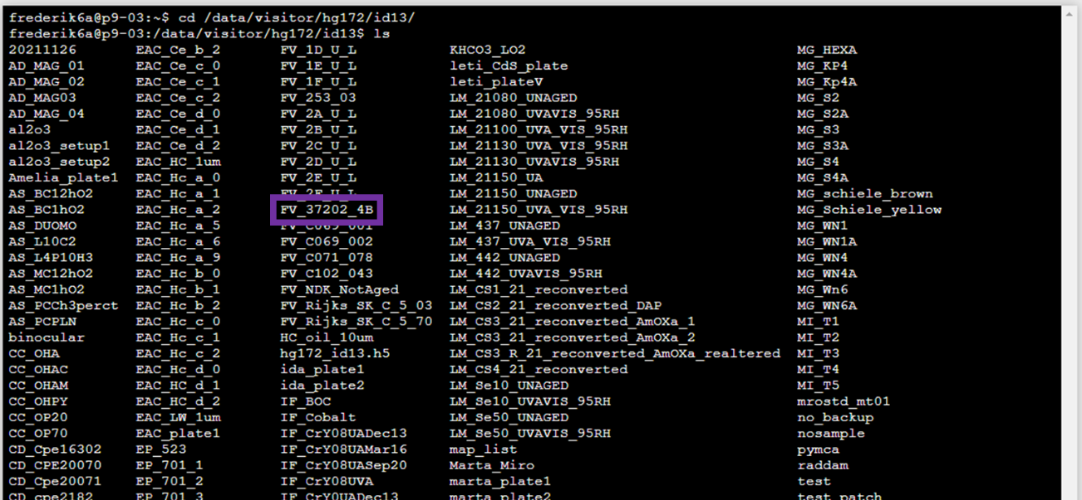
Inside each sample folder, you will find a folder for each measurement that was performed on this sample. Your dataset is inside this measurement folder.
Use the commands ‘cd’ and ‘ls’ to go inside a sample folder and list it contents and again to go inside the measurement folder and list it contents. The file that is required as input_file is inside the measurement folder. The input_file has the same name as the measurement folder and has the extension .h5.
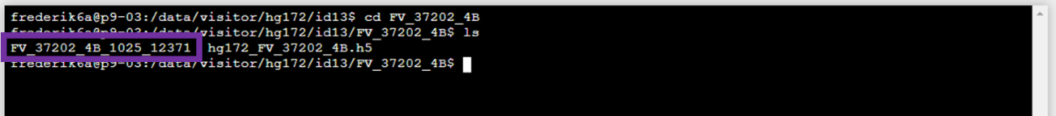
In the example above, the input_file is FV_37202_4b_1025_12371.h5 and it is located inside the folder FV_37202_4b/FV_37202_4b_1025_12371.
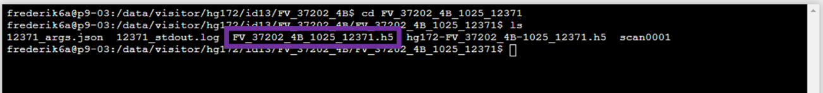

Common mistakes
Attention!
- There is a difference between Frederik and frederik. Take care to make sure that you correctly use CAPITAL letters or small letters.
- Be careful not to make typo’s or errors in the names of the directories
- Do not add white spaces in the red text
If you get an error in the next step (section 5), most likely you will have made a mistake while changing the red text.
The best way to avoid the above mistakes is to copy and paste as much as possible the text that you need to change. You can do this directly from the Terminal window into the run_config.yml file. In the example below I am changing my input_file by copying and pasting the filename of my dataset into the run_config.yml file.
In the Terminal window, you can select text using your mouse by clicking and highlighting the text that you need. You can then right-click and select Copy.
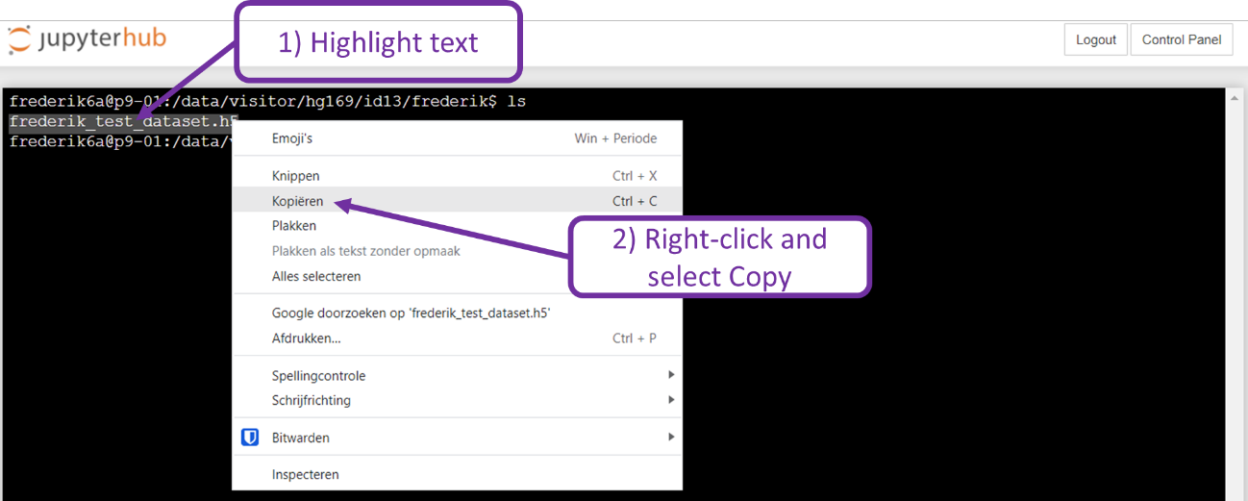
In the run_config.yml file, you can paste the text by right-clicking your mouse and selecting paste.
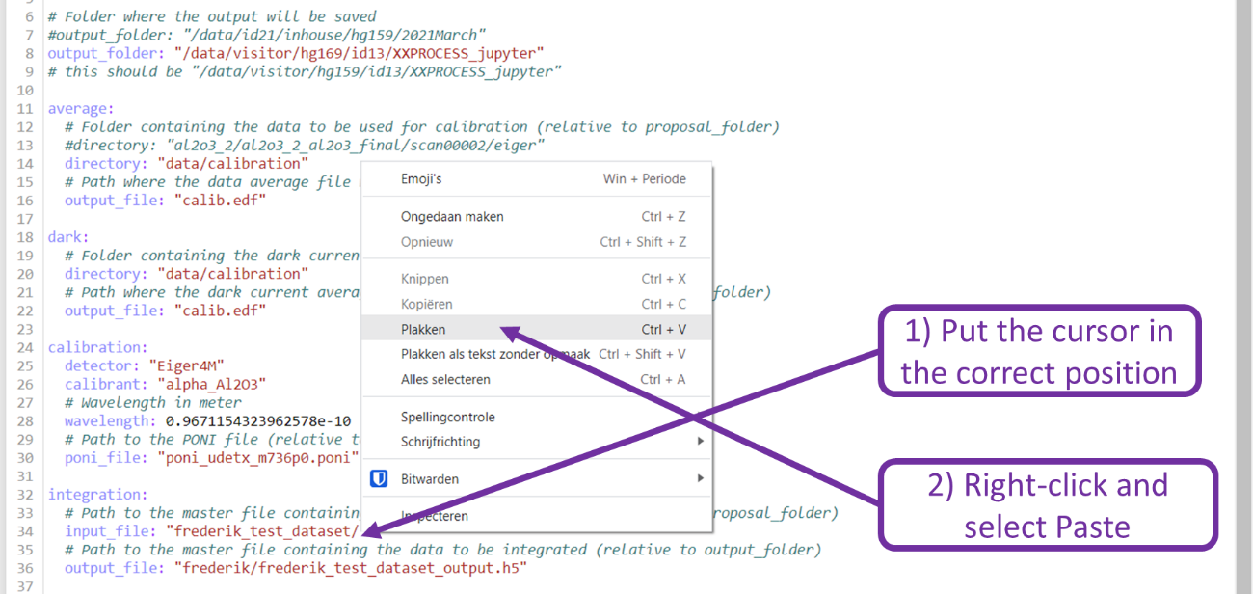

Run integration in 2a_integration_maps.ipynb

Integrate a single data set
In your Project window you will find several jupyter notebooks.
- 0_average_for_calibration.ipynb: to make an average 2D XRD pattern to use for calibration
- 0bis_average_dark_for_calibration.ipynb: to make an average dark image for the calibration
- 1_calibration.ipynb: determines the geometry of your detector and creates a .PONI file to be used during the integration
- 2a_integration_maps.ipynb: azimuthally integrates your dataset
- 3_linear_xrpd_fit.ipynb: performs a linear combination fit of your data with given reference files
Optional: More information about these notebooks can be found if you click Using_notebooks.ipynb in your Project window.
In this workflow, you only need to use the notebook 2a_integration_maps.ipynb. If you click on it a new window will open with the notebook.
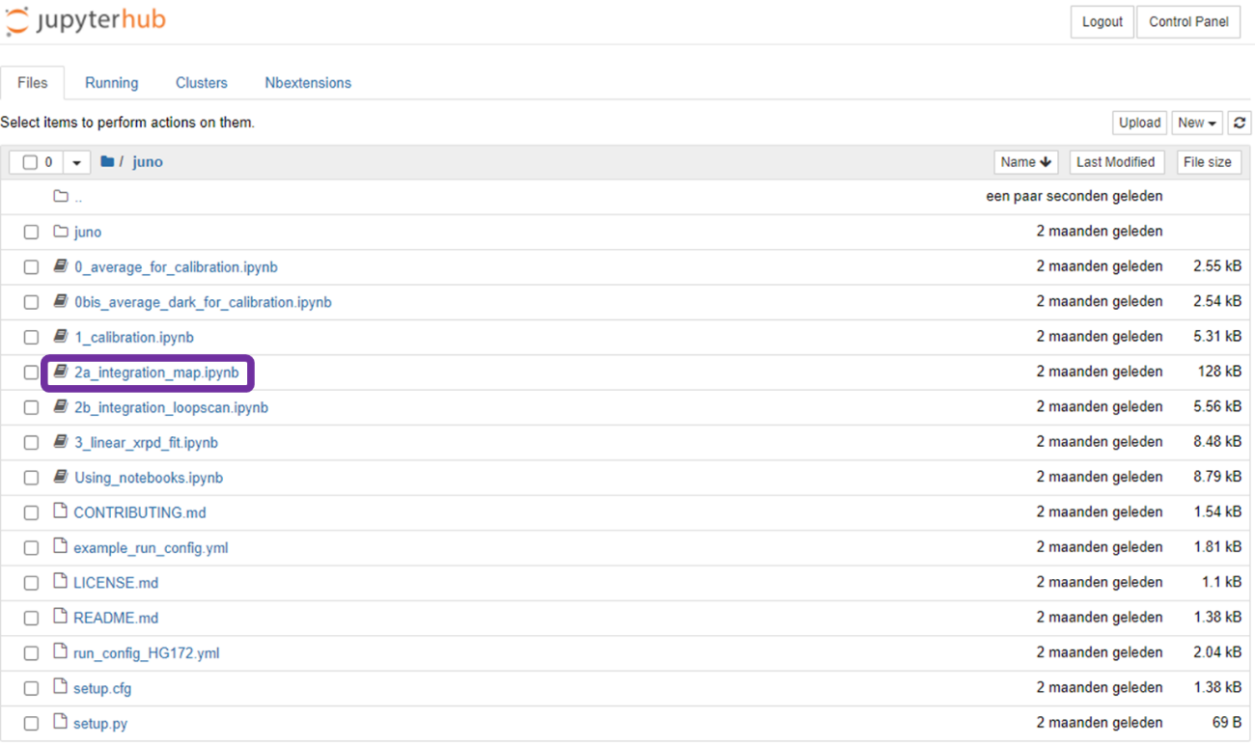

A notebook typically contains several sections with text and code. These sections are called cells. The code has a gray background and is grouped in a single cell.
In this notebook you do not need to change anything. What we need to do is to select the different cells of code by clicking on them once. When you have selected a code cell, a blue or green vertical line will appear on the left side of the cell. In the example below, the first code cell has been selected and shows a blue vertical line on the left side.
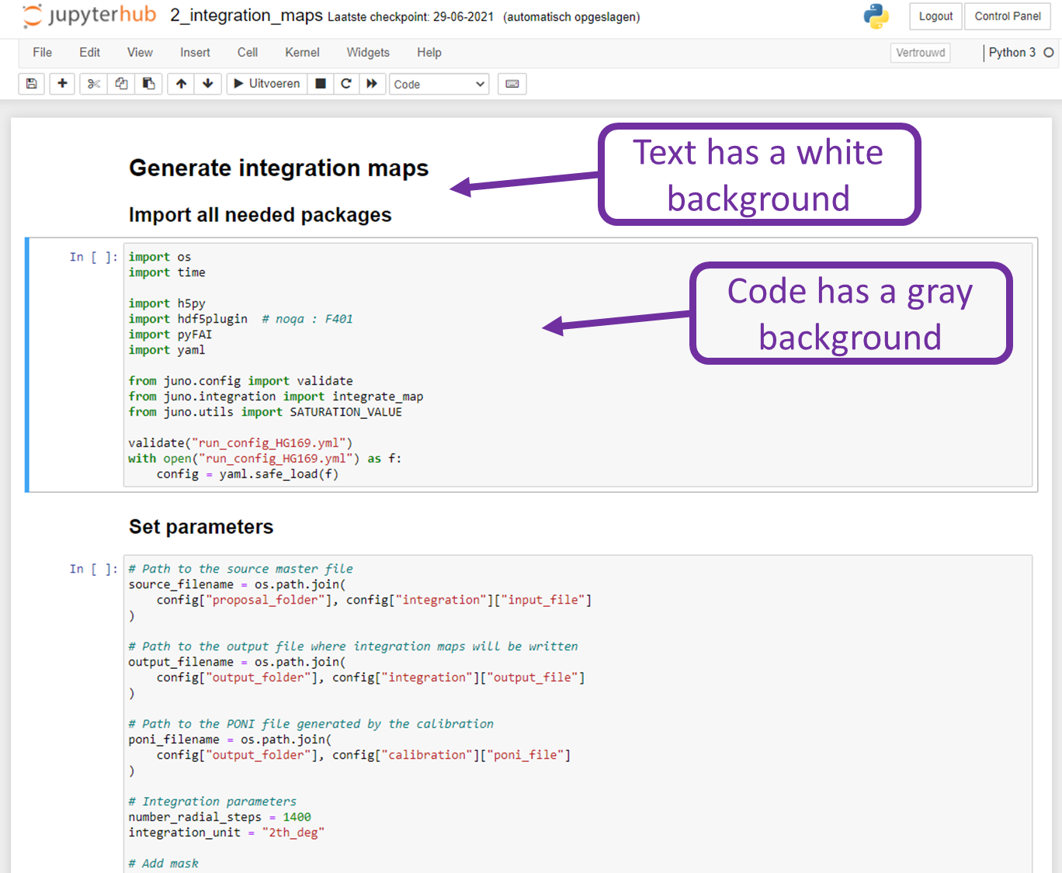

We need to select the code cells and run them one after each other to go through the integration notebook, see the scheme below.
- First, you need to select the first code cell underneath ‘Import all needed packages’ by clicking somewhere in the gray area.
- Then, you need to click on the ► Run. Since the language depends on your browser settings, this may read something different than ‘Run’.
- While the code is running an asterisk will appear between the brackets [*] and when the code has finished a number will appear in between the brackets [1].
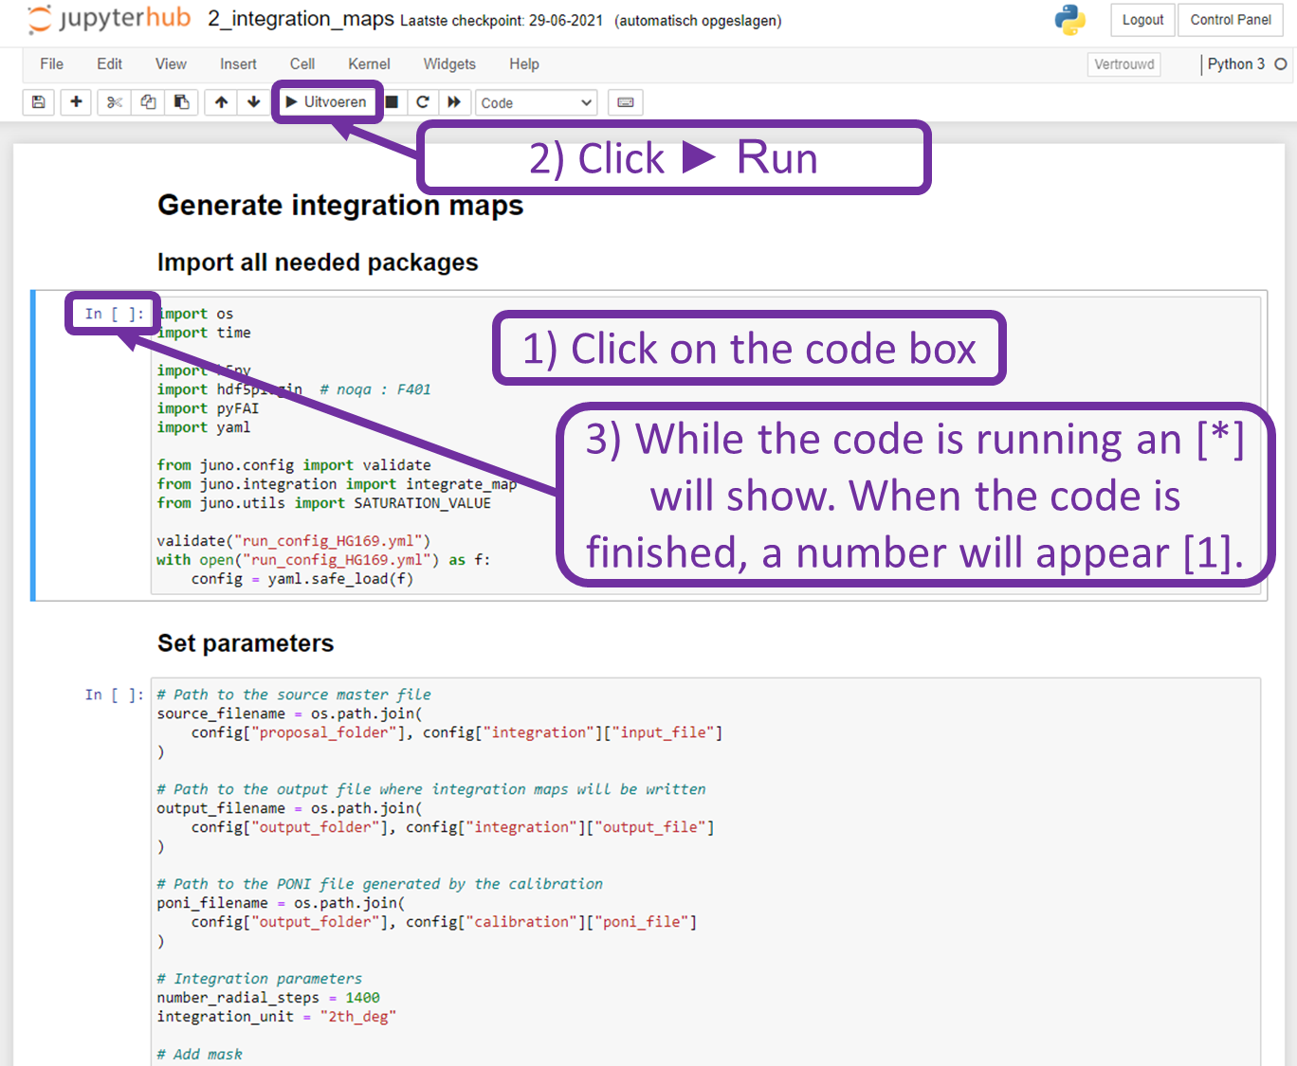

After running the first cell, all the packages that the jupyter notebook needs have been loaded.
In the second cell with code the parameters for the integration will be set. Again, you do not need to change anything in the code. You need to follow the 3 steps shown above, but now for the code cell that is shown underneath ‘Set parameters’ (i.e., click on the gray cell with code, press ► Run and wait for the code to finish).

The third code cell (the cell under ‘Launch integration’) will perform the actual integration. Again, click on the cell and press ► Run. Since this cell performs the actual integration, it will take some time for the code to complete. A status bar is shown in red just above the next cell.
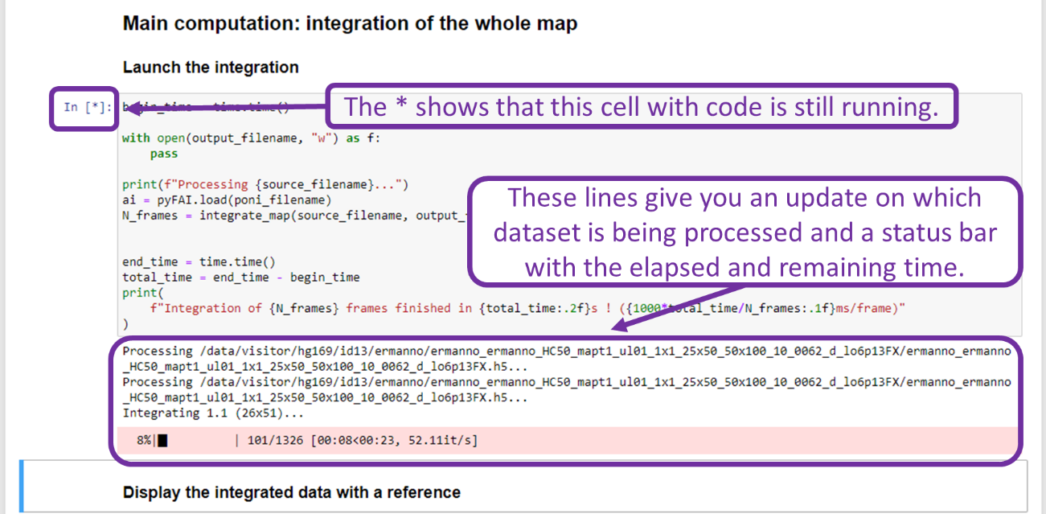

After the code has completed the integration, it will show the following message. Your data will have been saved in the folder XXPROCES_jupyter in a subfolder that you specified in the run_config.yml for the output_file (see section 4 of this workflow).

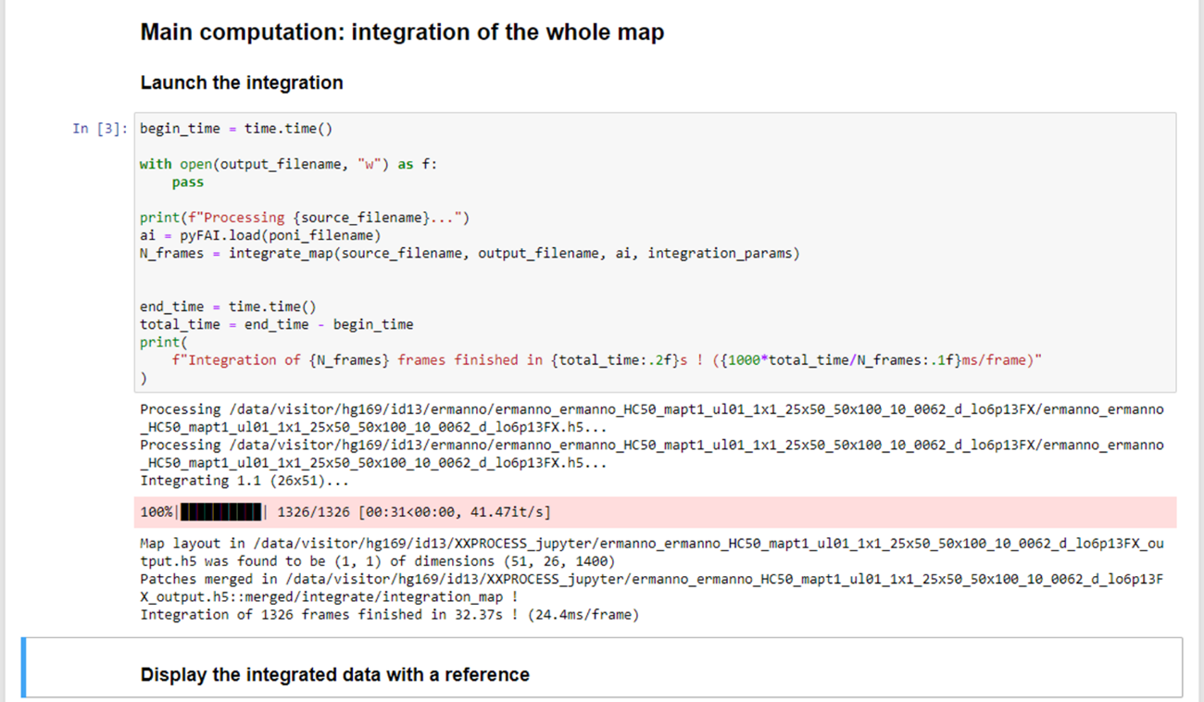
Congratulations! You have now successfully performed the azimuthal integration of your 2D XRD map. In the next step (Transfer and download your data) you can see how you can download this data.
Optionally, you can run several other cells in the current notebook (2a_integration_maps.ipynb), see 5.2.
If you want to integrate another data set, you need to restart the procedure starting from section 4. As long as your datasets are in the same proposal_folder, you only need to change the input_file and output_file in your run_config.yml file.

Optional
In the notebook 2a_integration_maps.ipynb several other code cells are present that already give you some first information about your sample. You can take a look at the average diffractogram of your dataset and get a first image of your map.
Averaged diffractogram
In order to get an average diffractogram of your dataset, click on the cell just below ‘Display the integrated data with a reference’ and run this cell. By default the reference silver behenate is selected (AgBh) and shown as red dashed lines over your diffractogram.
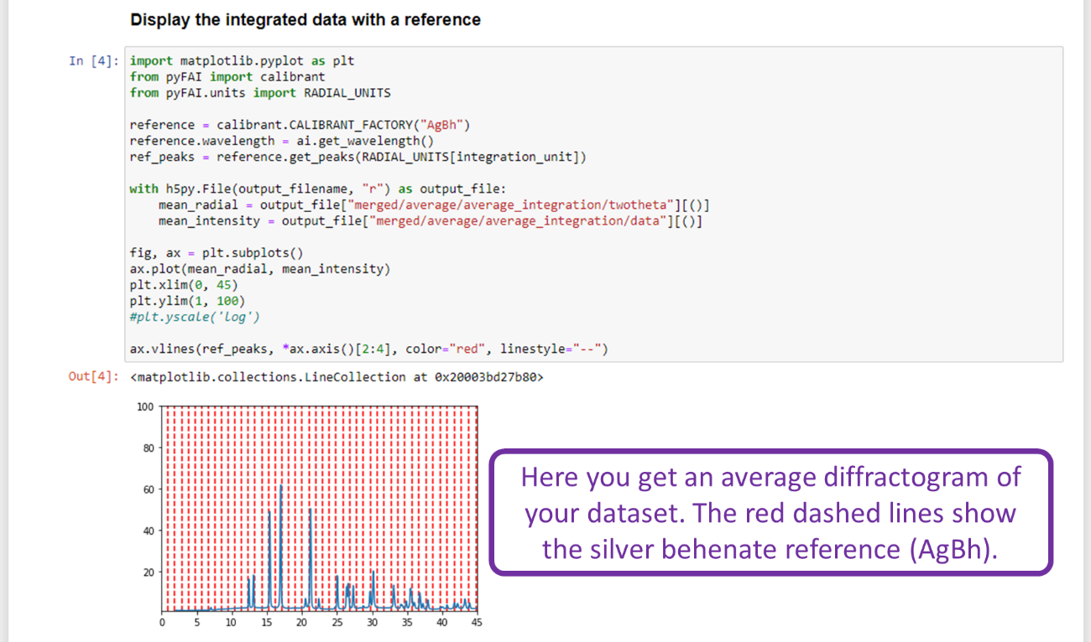

Display your map
In the next cell, you can take a first look at your map.
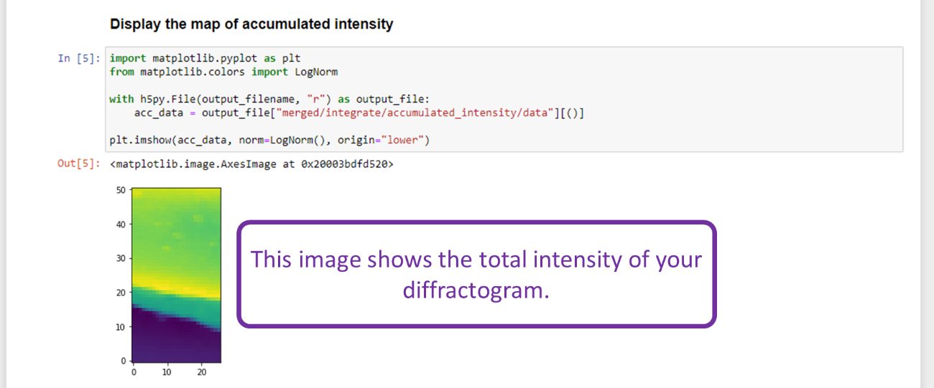

Convert data format
And lastly, you can convert the default file format of the integration (.h5) to the .edf format. The edf format can be loaded into the XRDUA software package for further processing of your data.
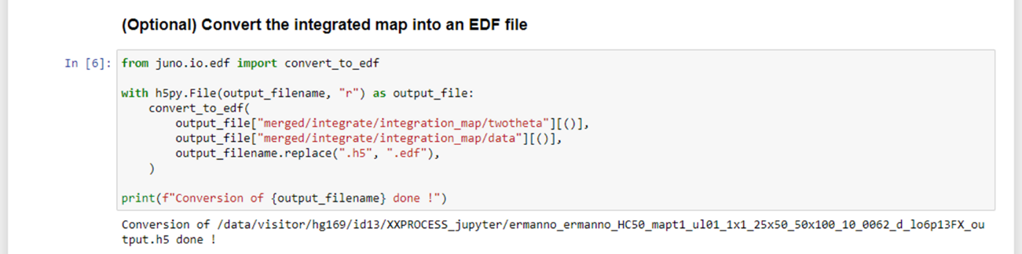

Transfer and download your data
In the Terminal window run the following command to activate additional functions
>> source /data/id21/inhouse/id21rc/bootstraprc
Go to the directory that contains the integrated files. This is the directory that you specified as output_file in the run_config.yml file.
>> cd /data/visitor/hg172/id13/XXPROCESS_jupyter/”your_INITIALS”
e.g., >> cd / data/visitor/hg172/id13/XXPROCESS_jupyter/FV
Optional: In case you processed multiple datasets you first have to make a single zip archive that contains these multiple files. The ‘ftpshare’ command in the next step can only transfer one file at a time. In order to zip multiple files and directories into one zip archive run the following command. This will make a zip archive of all the files in the current working directory. This may take some time depending on the size of your processed data.
>> zip -r “your_data_archive”.zip *.*
e.g., >> zip -r frederik_data.zip *.*
If you do not want to add everything to the zip archive, you can specify individual folders and/or datasets by separating them with a space.
>> zip -r “your_data_archive”.zip “folder1” “dataset1”.h5 “dataset2”.h5
e.g., >> zip -r frederik_data.zip folder1 dataset1.h5 dataset2.h5
You can then transfer your data to the ESRF ftp server. It is best to put the data in a folder with your name.
>> ftpshare “your_data_archive”.zip “your_ftp_folder” FV/.
e.g., >> ftpshare frederik_data.zip FV/.
You can use an ftp client to download your data from the ESRF ftp server or you can use your favorite web browser to go to http://ftp.esrf.fr/tmp/. Your data is stored in the folder tmp/”your_name”.
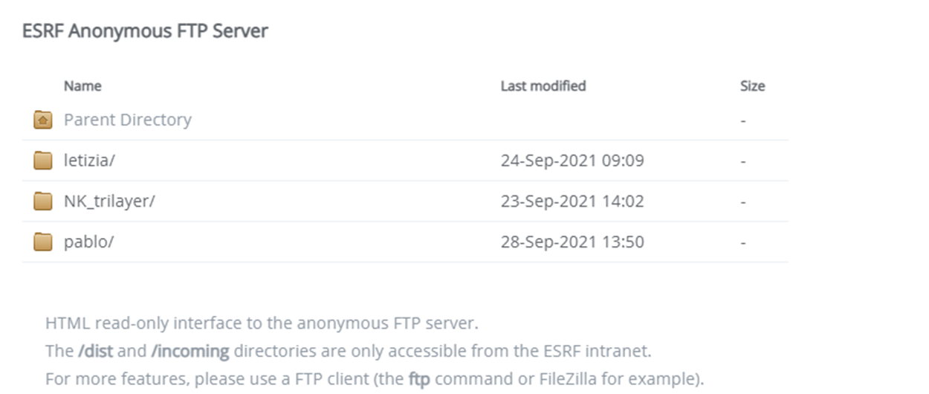

Update Juno
To update your Jupyter notebooks with the last modifications implemented by Loïc, please go to your juno folder and run the following commands in the Terminal window:
Go to your Juno folder
>> cd juno
“Stash” any changes that you might have made to your juno folder, so that you can put them back after the update
>> git stash
Get the update
>> git pull
Restore your own changes
>> git stash pop
The Jupyter scripts in your personal Juno folder are now up to date.
You can check the version of your Jupyter scripts using the following command
>> git log

