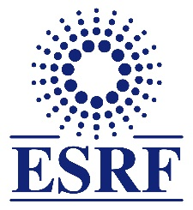
EUROPEAN SYNCHROTRON RADIATION FACILITY
INSTALLATION EUROPEENNE DE RAYONNEMENT SYNCHROTRON

ESRF User Office, CS 40220, F-38043 GRENOBLE Cedex 9, France
Tel: +33 (0)4 7688 2552, Fax: +33 (0)4 7688 2020
email: useroff @esrf.fr
______________________________________________________________________________
Use of the Electrochemistry Laboratory: User Declaration Form
This form is to be completed by all persons wishing to use the ESRF Electrochemistry Laboratory and has to be returned to the ESRF User Office at least 15 days before the beginning of the experiment.
Experiment title: | Proposal number:
 | Beamline:
Experiment dates: | Local Contact:

Persons authorized: (full name and affiliation of each person)) | Phone/fax/email

I certify that the persons named above
- have had sufficient training to enable them to work unattended in a chemistry laboratory;
- are qualified to handle inflammable, toxic or otherwise hazardous chemicals.

Date: _____________________ . ______________________________________
Signature of the Head of Department or Institute

When you have completed this form, please return it to the
ESRF User Office, CS 40220, F-38043 GRENOBLE Cedex 9, France
Tel: +33 (0)4 7688 2552, Fax: +33 (0)4 7688 2020, email: useroff@esrf.fr

For ESRF use
Copies to: | [ ] Safety Group  [ ] Martina Sandroni | [ ] Local contact  [ ] Helena Isern

